

FALCON’s Response to Flipkart for Supply of Loop CBS 40K PPH (Kolkata)
September 13, 2023

Kind Attention –
Mr. Hemanth Kumar
Mr. Arvind Seshadri
Mr. Sandesh Mulik
M/s Flipkart

Offer Ref: F23-00363-R1; Date: 13-09-2023

Subject – Techno -Commercial Offer of Loop Cross Belt Sorter 40K PPH

We are pleased to submit our Techno-Commercial Offer in response to your RFP.
As you will note, we have studied your requirements in great depth and, along with the information collected during the meetings and calls with you, we have put together a detailed technical proposal laid out in various sections and sequenced to enable you to understand our proposed solution and to re-enforce our commitment to being your partner in this strategic initiative.
In subsequent sections, we have highlighted the capabilities and experiences of Falcon Autotech with sections on our Intra-logistics Automation Technologies and references.
To conclude, I would like to add my personal commitment on behalf of Falcon Autotech. As we move through the RFP process, please do not hesitate to contact me and my team. We will be pleased to assist you with any further information or clarifications that you might have.
Best Regards,
Sandeep Bansal
Chief Business Officer

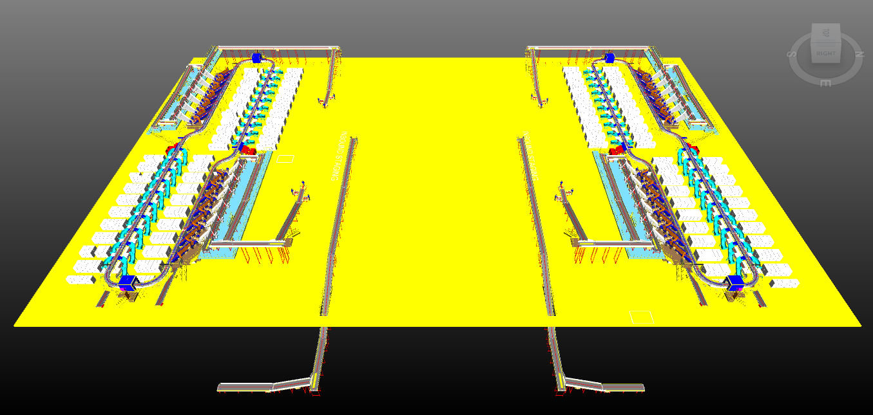

Proposal Reference – F23-00363-R1

Response to RFP for Loop Cross Belt Sorter 40K PPH Throughput
(Kolkata)

Falcon Autotech Private Limited
Plot No. 87, Sector Ecotech-1, Extention-1, Greater Noida, Uttar Pradesh 201308.

Contact – Sanyog Pratap Singh
Asst. Manager
Mob - +91 8750052591
Sanyog.singh@falconautoonine.com

Contents
Contents 4
1. Glossary 8
2. Executive Summary 9
3. Company Profile 10
4. Falcon’s Experience and Achievements in Sortation Space Globally 14
5. Reference Projects 16
5.1 Project 1- (CEP Client, UK) 16
5.2 Project 2- (CEP Client, Riyadh) 17
5.3 Project 3- (Client – Courier Express Shipment, Dubai & Jeddah) 18
5.4 Project 4- (CEP Client, Sydney) 19
5.5 Project 5- (Client – E-Commerce, India) 20
5.6 Project 6- (Ecommerce Client, India) 21
5.7 Project 7- (CEP Client, India) 22
6. Handled Shipment Spectrum 23
6.1 Shipment size loadable on the sorter 23
6.2 Shipments to be loaded on Sorter shall have the following characteristics: 23
6.3 Shipment not loadable on the sorter 24
6.4 Pictures of Sortable Shipments 25
7. Proposed System Description 26
7.1 Objective 26
7.2 Summary of the System 26
7.3 Main benefits of the proposed solution 27
8. Concept Description 28
9. Layout View 29
10. Proposed System Capacity Calculations 30
10.1 Sorter System Capacity 30
11. System description 31
11.1 Infeed System 31
11.1.1 Infeed System 32
11.1.1.1 Straight and Inclined Powered Belt Conveyor 33
11.1.1.2 Sliding Type Chutes 35
11.1.1.3 Idler Roller Conveyor 35
11.1.1.4 Plastic Modular Belt Conveyor 36
11.1.1.5 Diverter ARM 37
11.1.1.6 Tilted Belt VDS 38
11.1.1.7 Pros & Cones of ARM & Tilted Belt VDS System 38
11.1.1.8 VDS Chutes 39
11.1.2 Conveyor BOQ 40
11.2 Induction to Sorter 41
11.2.1 Feedlines 42
11.2.1.1 Buffer Conveyors 42
11.2.1.2 Weighing Conveyor 43
11.2.1.3 Orientation Conveyor 43
11.2.1.4 Intelligent Merge Conveyor 44
11.2.1.5 New Induct Fencing 44
11.2.2 Irregular Takeout Conveyor 45
11.2.2.1 Irregular Chute 45
11.2.2.2 Irregular Takeaway Conveyor 46
11.2.2.3 Irregular Collection Bin (In Flipkart’s scope) 46
11.2.3 Conveyor BOQ 46
11.2.4 Main Loop 47
11.2.5 Sorting Output 48
11.2.5.1 L-Type Collection chute 48
11.2.5.2 Rejection Chute 49
11.2.5.3 Chute Safety Net 50
11.2.6 Bag Take away Conveyor 51
11.2.6.1 Conveyor BOQ 51
12. Description of Components of Equipment 52
12.1 Cross Belt Sorter - 52
12.1.1 CBS Carrier 52
12.1.2 Servo Roller 53
12.1.3 Chassis 53
12.1.4 Carrier Wheels 53
12.1.5 Motor Drives 54
12.1.5.1 Friction Wheel Drive 54
12.1.5.2 Non-contact based linear motor drive 54
12.1.6 Power Transmission 54
12.1.7 Data Transmission 55
12.1.8 Carriers positioning System. 55
12.1.9 Technical specifications of Sorter 56
12.2 Scanning & Sensing on Main Sorter Loop 57
12.2.1 Automatic Barcode Scanning & Dimensioning System 57
12.2.2 Shipment Positioning System. 57
12.2.3 Empty Carrier Detection System 57
12.3 Steel Works – Mezzanine, Maintenance Platforms & Staircases- 58
12.3.1 Mezzanine 58
12.3.2 Maintenance Platform & Staircase 58
13. Allocated Areas 60
14. Proposed System Technical Details (Two Loops) 61
14.1 Mechanical equipment 61
14.2 Electrical Equipment 62
14.3 Control System 62
15. Electrical System 63
15.1 Reference Picture of Power Distribution Panel 63
15.2 Main Control Panel (Reference) 63
15.3 Induct Stations Control Panel (Reference) 64
16. Controls Architecture (Ref.) 65
17. IT Architecture (Ref.) 65
17.1 HAA Server (In Flipkart Scope) 66
18. Falcon’s WCS CONTROLIT 67
19. Falcon’s Visual Inspection System (SCADA) 68
19.1 FIELD DATA ACQUISITION 68
19.2 ANIMATED SYSTEM VISUALIZATION 69
19.3 ALARM MANAGEMENT 70
20. Key Components Make 71
21. Principle of Safety 71
21.1 E-Stops 71
21.2 Pull Cords Switch- 72
21.3 Fencing 72
22. Additional Scope- 73
23. Program Organisation 74
23.1 Program/ Project Schedule 74
23.2 Program Management 74
24. Flipkart Responsibility 74
24.1 Flipkart Responsibilities During the Assembly and Commissioning Phase 74
24.2 Responsibilities of Flipkart During the Tests 75
24.3 Flipkart Responsibilities During the Training 75
25. Warranty Period 76
26. Exclusions 77

Glossary

S. No. | Term | Description
1 | RFP | Request For Proposal
2 | PPH | Shipments Per Hour
4 | ICR | Intelligent Character Recognition
5 | MEZZ | Mezzanine
6 | FWD | Friction Wheel Drive
7 | ECDS | Empty Carrier Detection System
8 | AC | Alternating Current
9 | DC | Direct Current
10 | PLC | Programmable Logic Controller
11 | IT | Information Technology
12 | BOQ | Bill Of Quantity
13 | I/O | Input/ Output
14 | PDP | Power Distribution Panel
15 | PC | Personal Computer
16 | UPS | Uninterrupted Power Supply
17 | CBS | Cross Belt Sorter
19 | MDR | Motor Driven Roller
20 | DAP | Design Approval Phase

Executive Summary
Falcon is pleased to confirm its great interest in responding to this Flipkart RFQ of Loop CBS for Kolkata. Our team has been working closely with the relevant stakeholders, with a clear commitment to listening, understanding your needs, and ensuring this project's success.
Following the same objective for the Kolkata CBS system, we are happy to offer a compliant solution meeting all technical and operational requirements, high-performance, optimized, tailor-made, fast and secure planning, and a competitive price.

Our solution is based on the following key characteristics:

• Two loops of shipment sorting, employing our cross-belt technology, have been designed to handle a throughput of 20,000 packages per hour on each loop.
• Each loop is equipped with its own infeed conveyor system, comprising two distinct infeed lines.
• Within each loop are two induction zones featuring six induct lines.
• In each loop, there are 40 secondary chutes (L-Type) and four rejection chutes.
• The system layout has been meticulously planned to facilitate smooth operational flow, ensuring efficient movement of personnel.
• Furthermore, additional conveyor automation is implemented, connecting the lower level to the inbound staging area.
• Lastly, beneath the CBS is a set of bag takeaway conveyors, and provision of irregular shipments take out is provided beneath the induction zone.

A tailor-made and simple layout designed explicitly for Flipkart. The proposed layout is the result of the technical requirements in the RFP document and our discussions with the relevant stakeholders during our meeting.

- Falcon's reliable Shipment sortation systems
These systems are globally being used by most innovative brands such as Amazon, Delhivery, Asendia, Fastway and many more. The main and critical components of the FALCON Autotech sorter building blocks, like wheels, motors, belts, bearings, Bus Bars, Communication platforms, PLCs etc., are sourced from some of the best suppliers in the world, such as SEW, Siemens, SICK, Faigle, Vahle and Forbo. This strategic baseline of sourcing policy allows Falcon's customers to be fully confident in the systems' robustness and reliability.

- Commitment to quality systems
Demonstrating Falcon's clear commitment to the Flipkart satisfaction, the shipment sortation system, parts and services will be under warranty for 12 months from installation go-live.

- A strong and already successful partnership between Flipkart & Falcon
Flipkart has been Falcon's customer since long and using multiple Falcon Systems and now a new shipment sortation system of 20,000 PPH is being installed at the Ulluberia location of the Flipkart network. For each of these projects, several advanced tools to improve the service's quality and efficiency are provided: Service Desk, Hotline support, remote access, regular governance meetings and monthly reports.

Company Profile
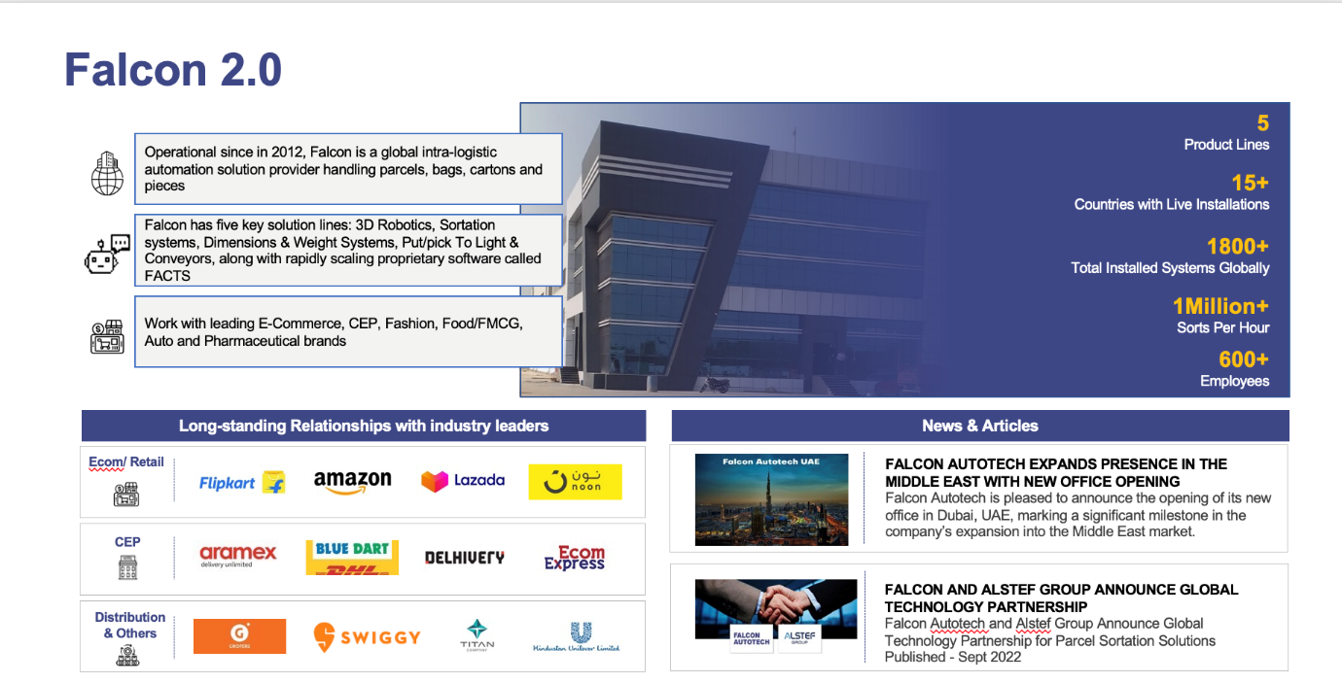
Falcon Autotech (Falcon) is a global intralogistics automation solutions company. With over 10 years of experience, Falcon has worked with some of the most innovative brands in E-Commerce, CEP, Fashion, Food/FMCG, Auto and Pharmaceutical Industries. With our proprietary software and robust hardware integration capabilities, Falcon designs, manufactures, supplies, implements, and maintains world-class warehouse automation systems globally. Falcon’s strong research and development team and the continuous focus on innovation reflect our strong solution line around Sortation, Robotics, Conveying, Vision Systems and IOT. Falcon has done over 1,800 installations across 15 countries on four continents.

Falcon Autotech is currently among the top 15 intralogistics automation company, our vision is to become top 10 intralogistics automation company in our focused product lines.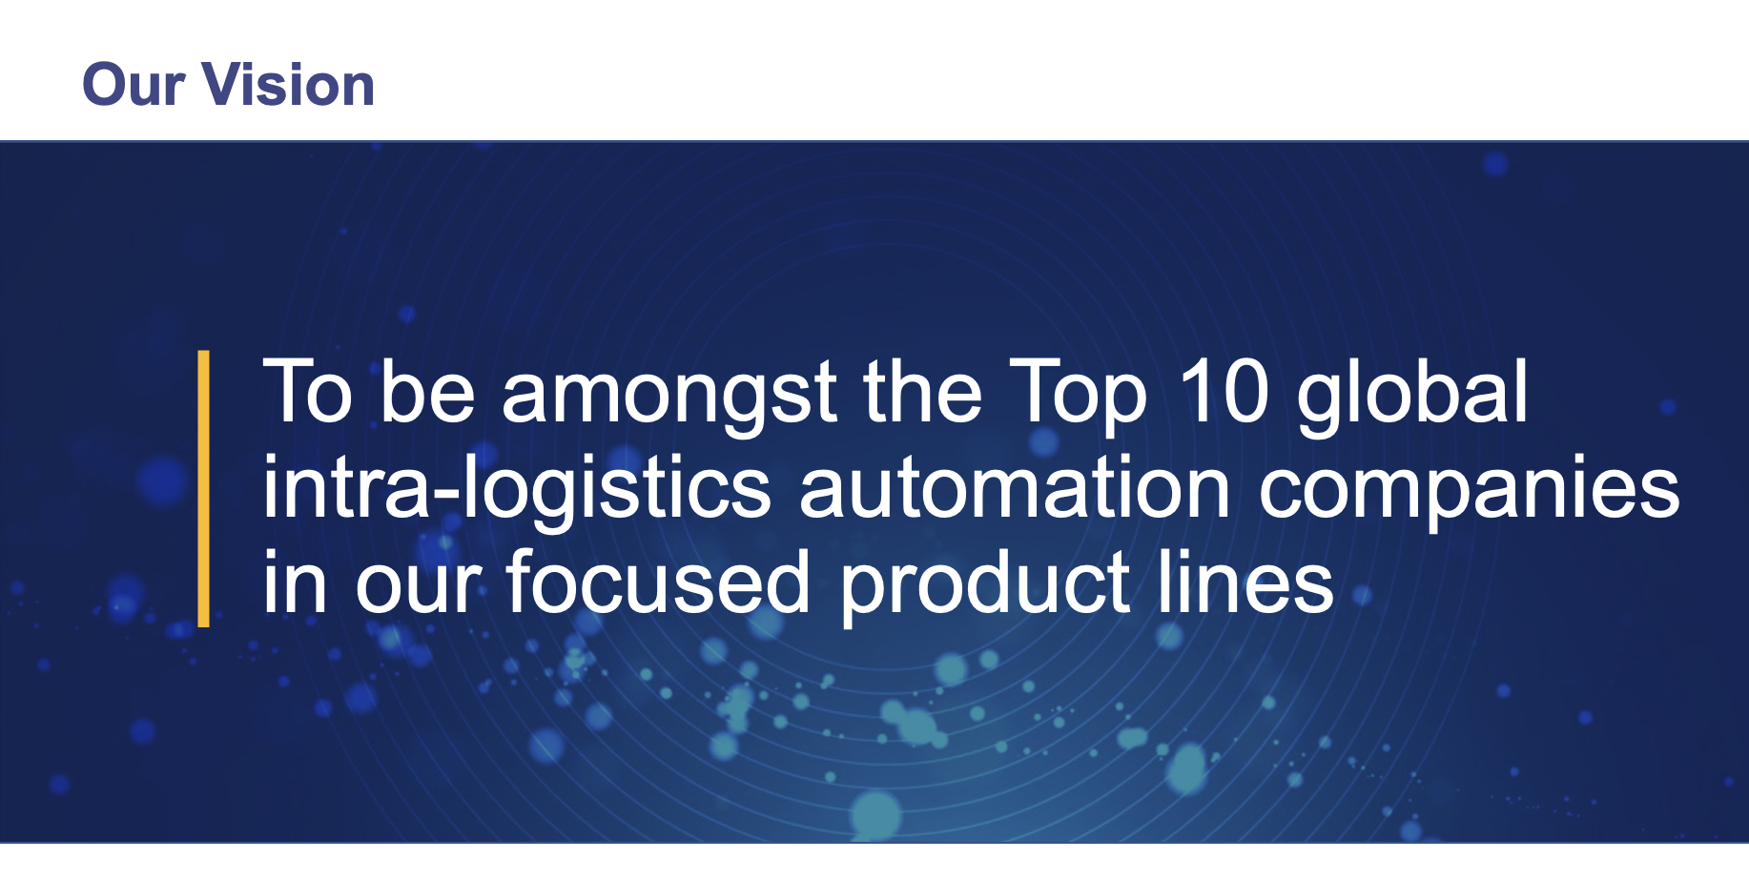

The team started out in 2004 solving special purpose automation problems for clients and later established Falcon Autotech in 2012 with strong focus on building standard technology stack spanning across Hardware, Firmware and Software to tackle bigger Supply Chain problems around warehouse automation and material handling. Over the decade, Falcon has made rapid strides and has carved out a niche in some of the world's most cutting-edge technologies: Sortation, Robotics, Conveying, Vision Systems and IOT.
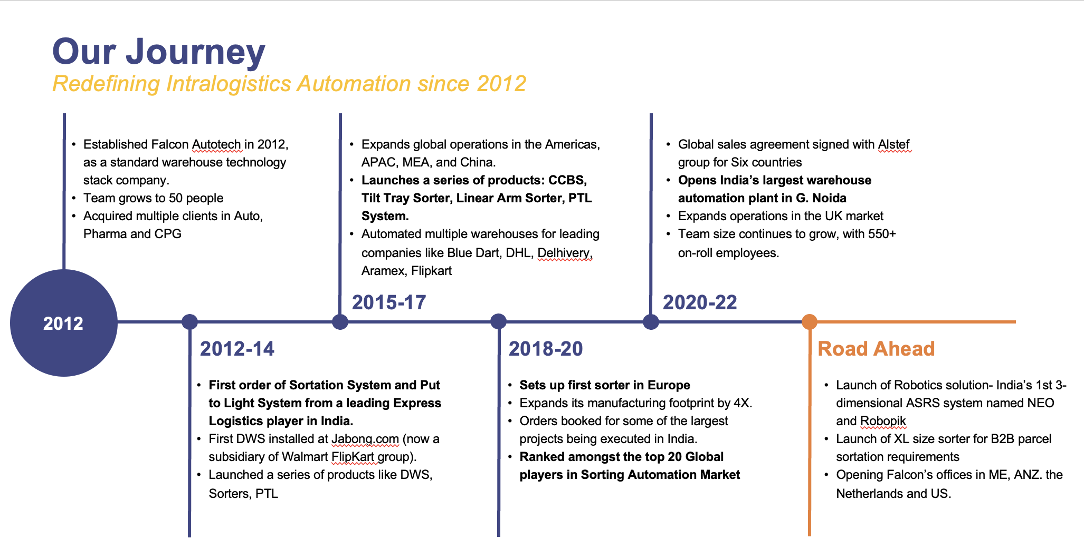
As a leading player in the intra-logistics automation space, Falcon continuously strives to improve the operational efficiencies and accuracies for its clients through its domain knowledge and experience in addition to its wide range of products and solutions. In order to be able to live up to the high expectations set forth by our clients, the team at Falcon realizes the importance of taking up selective applications in focused Industries and deliver world class projects in return.
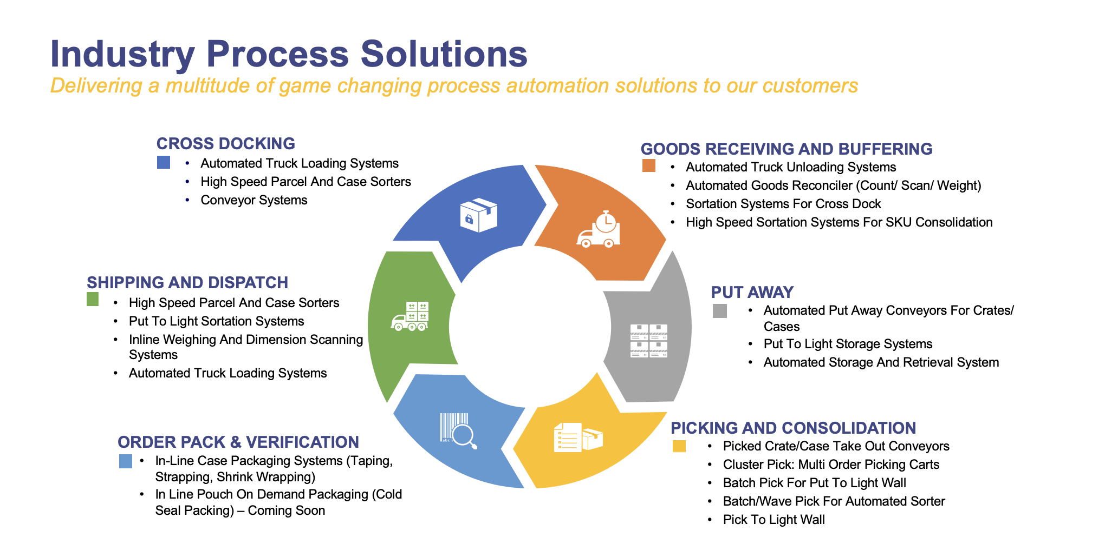

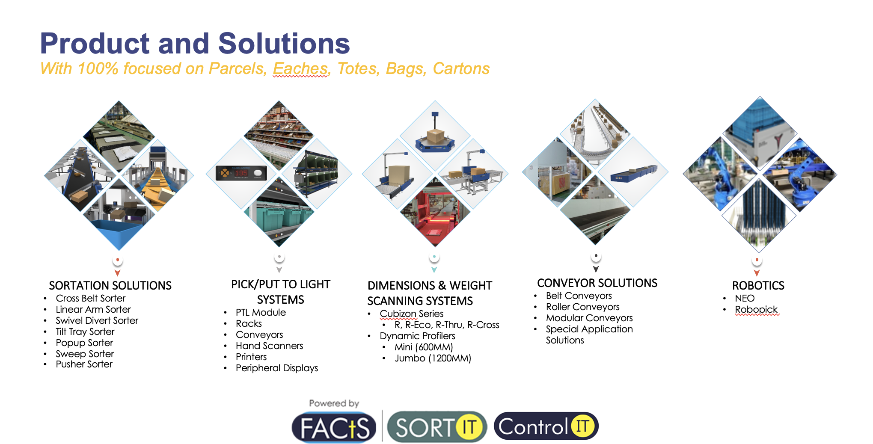
Falcon Autotech has successfully delivered warehouse automation solutions based on smart and innovative combinations of above product lines for effective materials handling, sortation and movement. The process is controlled in real-time by our in house WCS applications. These solutions considerably cut the need for manual operations, improve working conditions and ensure the highest accuracy of the entire process up to final delivery to the recipient.
Over the last 10 years, Falcon has worked with some of the most innovative brands worldwide and has established long standing partnerships. These brands are testimony of our strong focus on delivering superior customer satisfaction and offering end-to-end intralogistics solutions.
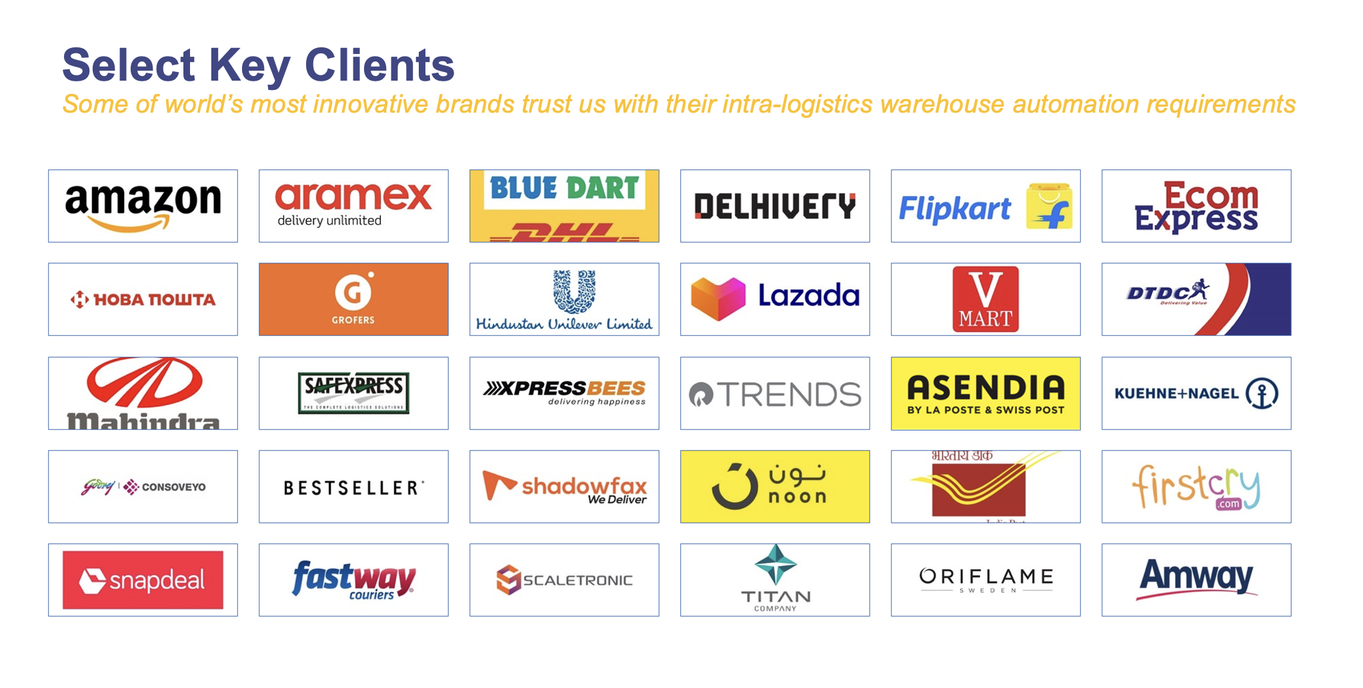

With over 1,800 installations, today Falcon’s systems are used all over the globe. Falcon has highly motivated team of 600+ employees supported by over 15 global partners who help us design, manufacture, deliver and maintain automation solutions globally.
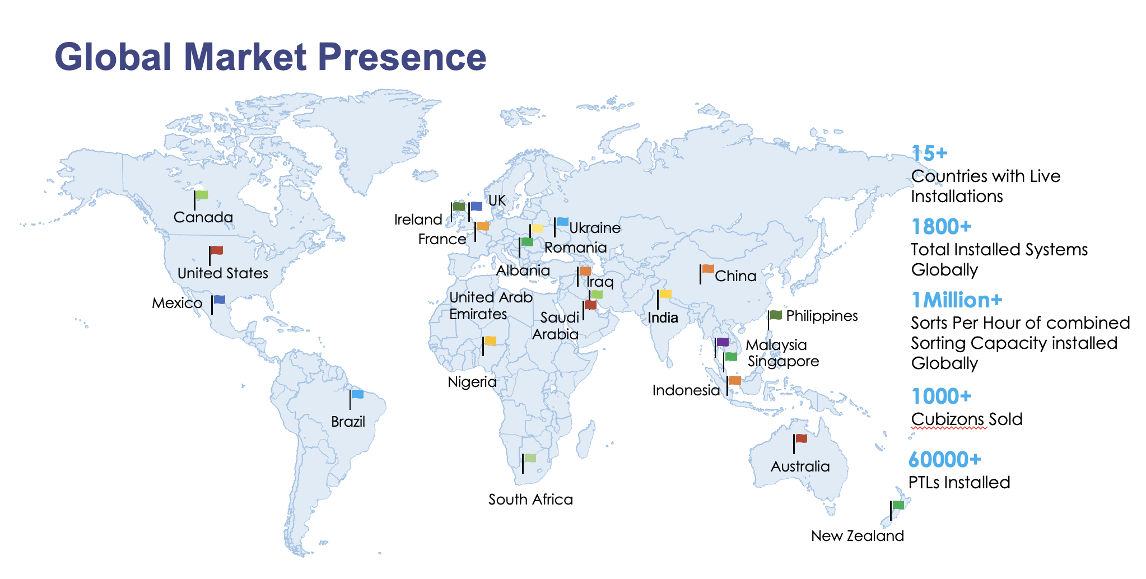

Falcon’s Experience and Achievements in Sortation Space Globally
- Ranked among Top 20 Sortation System Suppliers globally. Only company from APAC/EMEA Region.
- Currently possess one of the World’s largest portfolios in Sortation Technologies: 7 In-house technologies.
- Total installed capacity of 10 million Shipments per day worldwide.
- Only company to be able to offer a Fully Integrated AMS.

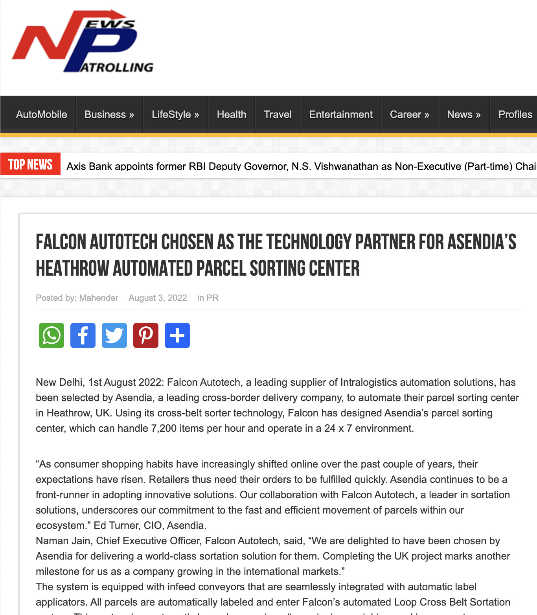




Reference Projects
Falcon has a strong legacy in Warehousing Automation solutions and references-

- Expertise in Shipment Sortation, Piece Picking and Handling, Case Picking and Handling.
- Lifecycle services (maintenance, spares supply chain, support).
- Full in-house expertise (Hardware/Software).
- Turn-key tailored solutions.
The references list presented below focuses on Sortation Solution –

Project 1- (CEP Client, UK)
This Solution is designed to handle a volume of 7200 shipments per hour. The system is equipped with three infeed conveyors integrated with an automatic label applicator before shipments enter the sortation system. The shipments are sorted using Falcon's Loop Cross Belt Sorter equipped with automatic barcode scanning, dimensioning, weighing and image capture capabilities. The sorter is installed on the mezzanine floor and sorts directly to 58 end destinations.
Solution Specifications –
- Throughput: 7200 PPH
- End Destinations: 58 Nos
Key Technology Modules –
- Powered Belt Conveyors.
- Automatic Induct Lines.
- Automatic Barcode Scanner with Image Capture.
- Automatic Weight & Volume Measurement System.
- Loop Cross Belt Sorter.
- WCS Software System.
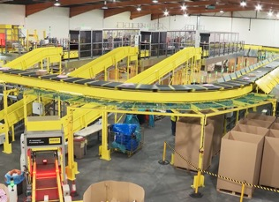
Site Picture –

Project 2- (CEP Client, Riyadh)
In 2019, customer selected Falcon Autotech as a preferred supplier for its airport hub to supply linear cross belt sorter for processing of shipments arriving via Air from different states and countries to distribute them locally. The customer chose Falcon Autotech based on its strong track record of success in providing intralogistics automation solutions, optimized design, software integration capabilities and life cycle support services.
Solution Specifications –
- Throughput: 4800 PPH
- End Destinations: 52 Nos
Key Technology Modules –
- Powered Belt Conveyors.
- Automatic Induct Lines.
- Automatic Barcode Scanner with Image Capture.
- Automatic Weight & Volume Measurement System.
- ARB Conveyor.
- Automatic Label Applicators.
- Linear Cross Belt Sorter.
- Specialized Chutes for Gentle Shipment handling.
- FOCR Engine.
- WCS Software System.
Site Picture –
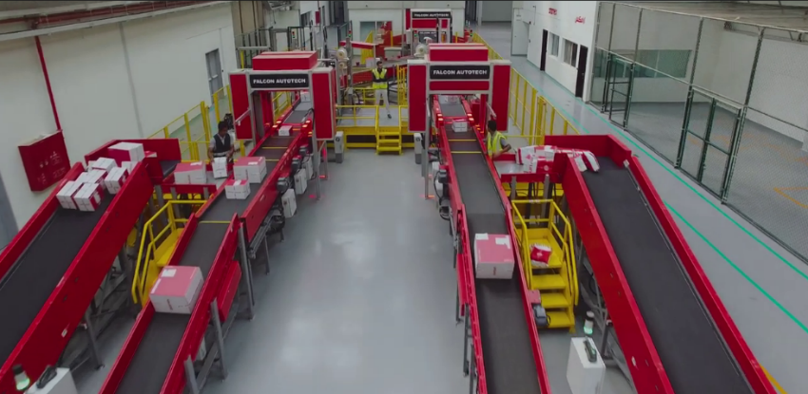

Project 3- (Client – Courier Express Shipment, Dubai & Jeddah)
This Solution is designed to handle the bulk volumes through Launchpads and induct them into Falcon's Linear Arm Sorter. This system is designed for a throughput of 3000 shipments per hour equipped with automatic barcode scanning, dimensioning, weighing and image capture capabilities to into a total of 480 end destinations with a combination of primary and secondary sortation system. The secondary sortation is achieved by integrating put to light system.
Solution Specifications –
- Throughput: 3000 PPH
- End Destinations: 480 Nos
Key Technology Modules –
- Powered Belt Conveyors.
- Linear arm sorter.
- Automatic Barcode Scanner.
- Automatic Weight & Volume Measurement System.
- WCS Software System.
Site Picture –
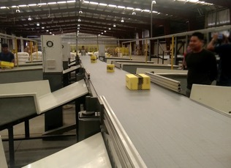

Project 4- (CEP Client, Sydney)
Solution is designed for handling a throughput of 16,000 shipments per hour with the help of Falcon’s Loop Cross Belt Sorter. The system consists of 2 feeding zones with a total of 10 feedlines. Sorter design enables the van drivers to directly drop the shipments at the dock doors. It has a total of 369 end destinations that are achieved with a combination of direct drops and PTLs. System is integrated with 5 side automatic barcode scanning, weight and volume measurement and automatic detection of oversize and overweight shipments.
Solution Specifications –
- Throughput: 16000 PPH
- End Destinations: 369 Nos
Key Technology Modules –
- Powered Belt Conveyors.
- 2 Induct zone.
- 5 side Automatic Barcode Scanner.
- Automatic Weight & Volume Measurement System.
- Automatic detection of oversize shipment.
- Loop Cross Belt Sorter.
- WCS Software System.
Site Picture –
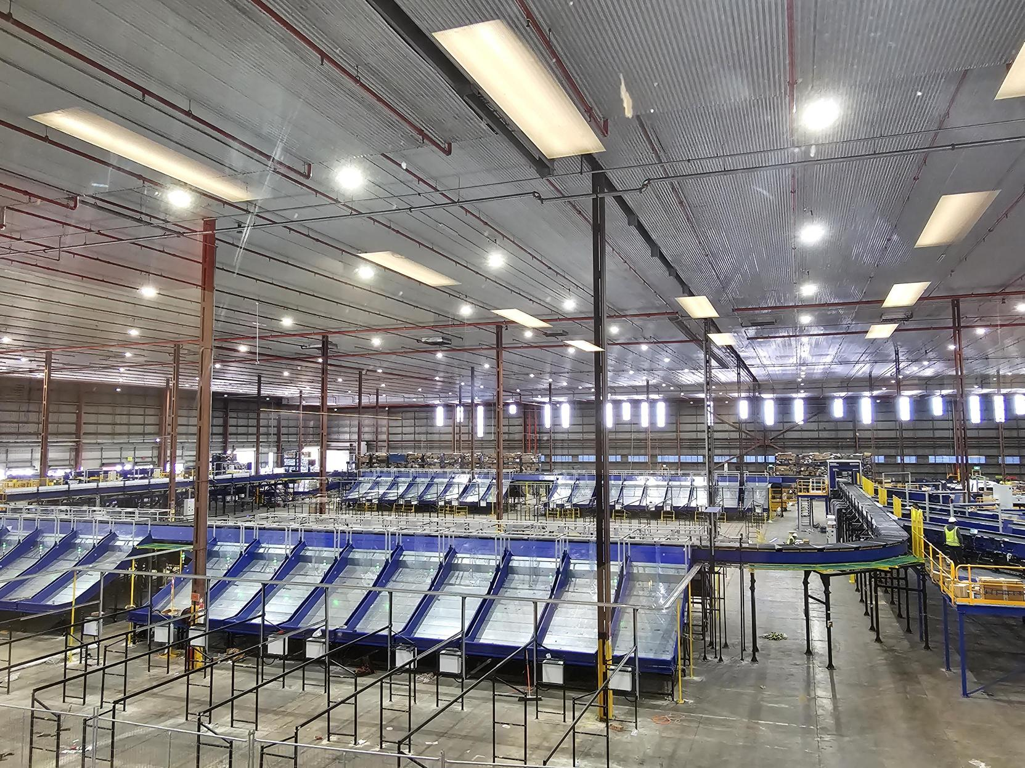

Project 5- (Client – E-Commerce, India)
Use Case – Destination Sorting of Packed Shipments.
In 2019, Client was looking for a potential automation partner for design and development of a new automated sortation system for B2C shipments. The system should be able to provide maximum uptime with reduced dependency on skilled manpower, and space optimization.
The customer chose Falcon Autotech based on its unique design which could cater to all their pain points, capability of seamless integration with WMS and life cycle support services.
Solution Specifications –
- Throughput: 27,600 PPH
- End Destinations: 410 Direct Outputs
- Building Size: 200,000 Sq Ft
Key Technology Modules –
- Bulk Infeed Conveyors.
- ARB based Volume Distribution System
- Integrated Presort System.
- Irregular Ejection System.
- Automatic Induct Lines.
- Automatic Barcode Scanner with Image Capture.
- Automatic Weight & Volume Measurement System.
- Loop Cross Belt Sorter.
- Smart Sliding Chutes for Direct bagging and Cage Sorting.
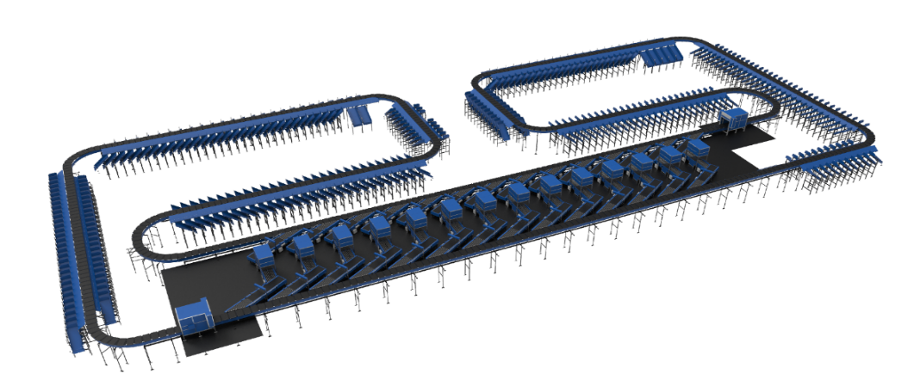
- Bag take out system
- WCS Software System.

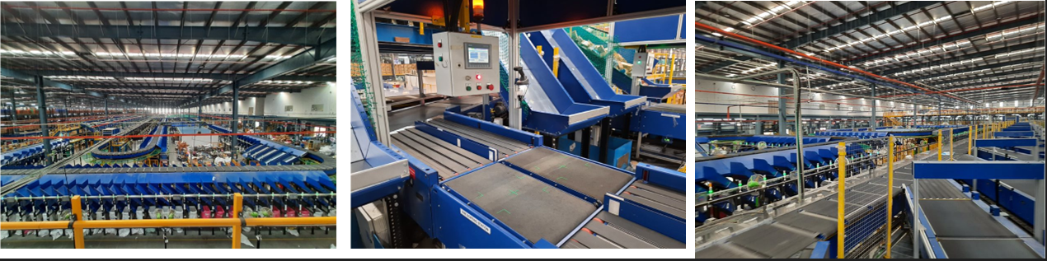

Project 6- (Ecommerce Client, India)
Use Case - Destination Sorting of Packed Shipments
Solution Specifications –
- Throughput: 24,000 PPH
- End Destinations: 110
- Building Size: 200,000 Sq. Ft
Key Technology Modules - Loop Cross Belt Sorter with a cell size of 900 x 500 mm
Layout and Site Pictures -
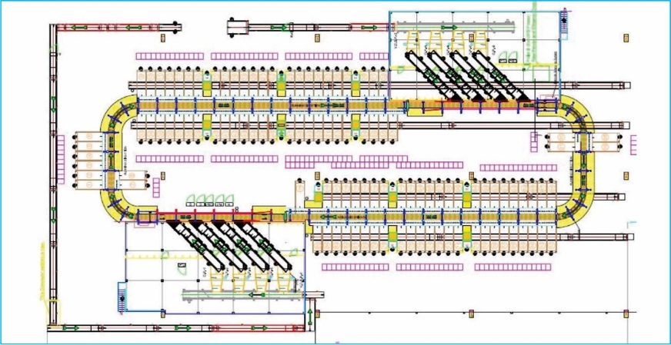

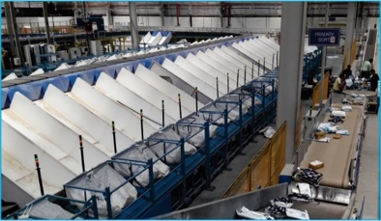
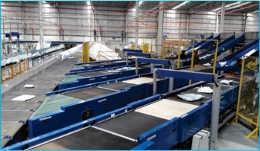

Project 7- (CEP Client, India)
The System is equipped with two fully automated and interconnected Sub-systems. Sub-System 1 is designed for handling large B2B boxes and E-commerce shipment bags while the Sub-System 2 is designed to handle Small E-commerce packages.
Solution Specifications –
  - 48,000 PPH (Double Deck CBS- Shipment Sorter)
  - 17,000 PPH (Double Deck CBS- Bag Sorter)
- Building Size: 700,000 Sq. Ft
Key Technology Modules –
- 2 Sets of Double Decker CBS Sorters
- Mezzanine Structures (one large mezz on to install a double decker Sorter).
- Automated Singulators
- Fully Automatic Inductions
- Semi-Automatic Inductions
- Telescopic belt conveyors
- PVC Belt Conveyors
- Modular Belt Conveyors
- Spiral Chutes with Braking rollers
- 5-Sided Scanning Tunnels
- High speed weighing conveyors
- Direct Bagging Chutes
- Put to Light Chutes
- Volume Distribution systems
- High Availability Server Systems
- WCS
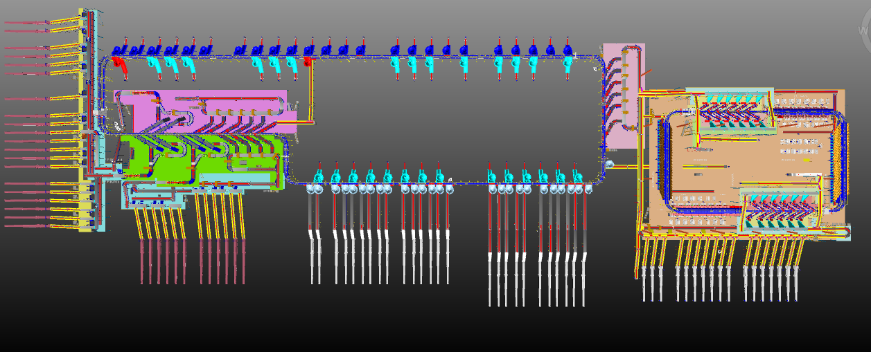
Layout -

Handled Shipment Spectrum
As per the shipment spectrum data provided in the RFP documents, Falcon has studied and analysed the shipment spectrum in detailed.
Falcon purposes to use its “Single Belt Cross Belt Sorter” to provide the maximum benefits to Flipkart in-terms of handling large shipment sizes and weight.

Shipment size loadable on the sorter
Falcon’s Cross belt sorter has a capability to handle the below mentioned shipment sizes and weight.

Specification | Unit | Value
Max Length | mm | 600
Max Width | mm | 400
Max Height | mm | 300
Max Weight | Kg | 10
Min length | mm | 100
Min Width | mm | 100
Min Height | mm | 3
Min Weight | gm | 100

Shipments to be loaded on Sorter shall have the following characteristics:

- Centre of Gravity of item must not move during conveyance or sorting.
- Item must not have magnetic content, otherwise behavior of shipment cannot be guaranteed.
- Liquid or fragile material, to avoid breaking, spillage or leakage, such as wine bottles, metal cans of paint are designated as non- conveyable items.
- Shipments shall be perfectly and safely packaged: protrusion or open surfaces are not allowed.
- Plastic ropes shall be perfectly adherent to the surface of the package.
- All items with the risk of being damaged during the transport on an automatic sorting system or
damaging the sorting system. They must be robust enough to avoid disintegration of container material and loose of contents in the sorting process.
- Item packaging shall have enough grip to be handled on the belts during the acceleration and
referencing phases.
- Items shall not have slippery surfaces and must be able to withstand acceleration of the items on the belt during the start-stop phases (accelerations up to 0.5 g shall be assured without any sliding or tumbling of the items on the belt conveyor).
- The shipments must have at least one flat and regular surface providing enough stability during conveyance.
- All shapes are permitted except spherical, cylindrical, or alike unstable items & shapes.
- All usual packaging materials are permitted (including paper, carton, plastics, plastic foil, rope, tape, textile, and wood)

Shipment not loadable on the sorter

All products that are not within the range as described here, are considered non- conveyable products, and must be taken out of the main sorter flow by the operators.

- Unstable items with a risk to roll or tumble on the sorting system, such as spherical or cylindrical items.
- Items that have a spherical or cylindrical shape.
- Items that are packed in material that can damage the conveyors or the sorter.
- Items that have sharp points (e.g., Nails) or sharp edges, that can damage the conveyors or the sorter.
- Fragile shipments with contents not sufficiently secured.
- Items that have been classified as dangerous are designated.
- Wet items are designated.
- Items with anti-slip treatment.
- Items with protruding parts.
- Items with sharp edges.
- Inadequately packed items that could be damaged during automatic transportation.
- Electrostatically loaded items.
- Loose parts on loads and load carriers, such as adhesive tape, stickers, slips of paper, straps, wrap foil etc. are designated as non- conveyable items.

Pictures of Sortable Shipments
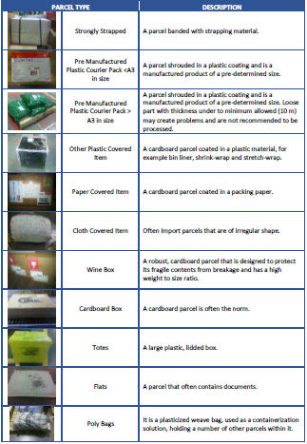

Proposed System Description

Objective
The purpose of this proposal is to present the design, manufacturing, installation, commissioning, testing, and acceptance testing of the Loop CBS for sorting shipment as per Flipkart’s logic.
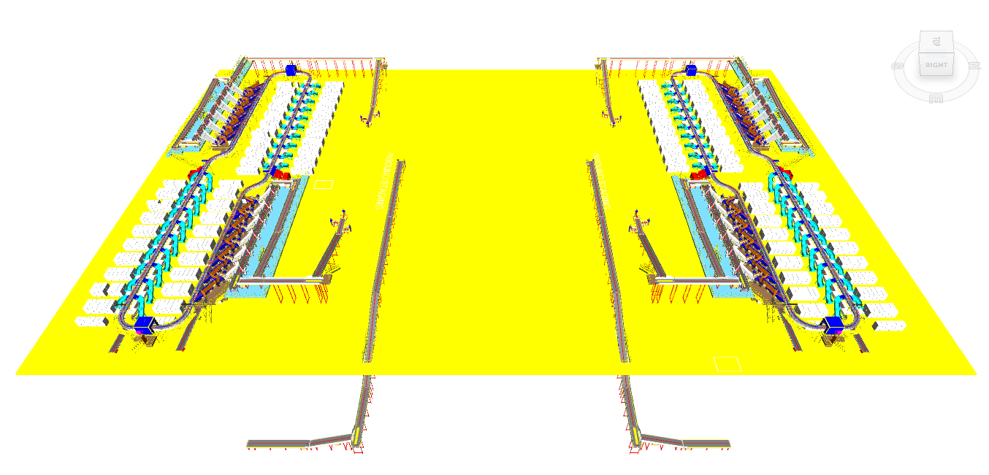

Summary of the System

Process flow of the Loop CBS System-
- Infeed System: - Shipments enclosed in bags are manually placed onto the belt conveyors, which then convey the bags from a lower level (below the mezzanine) to the inbound staging area located on the mezzanine.
The bags are unsealed, and the shipments are dumped in bulk onto the infeed lines of the VDS system. Subsequently, the bulk shipments ascend to a higher level and arrive at the VDS system. Once the shipments are within the VDS loop, they are evenly distributed among all inducts.
- Inducts: - After the shipments are collected in the VDS chute, an operator picks and positions each shipment on the induct line, ensuring that the shipment is properly aligned and that its barcode is facing upwards. The feedlines then automatically induct the shipments onto the Cross-Belt Sorter Loop.
Non-Conveyable Shipments are placed in the Non-Con chute, which is located beneath each operator position. The Non-Con chute is connected to the conveyor, which transports the shipment out of the induct mezzanine as needed by Flipkart.

- Loop CBS: - Once the shipments have entered the main loop, the Cross-Belt Sorter (CBS) efficiently sorts the shipments into their respective output chutes by utilizing the data provided by Flipkart's sorting logic.
- Output Chutes: - The shipments are discharged into two types of chutes.
  - Secondary Chute (L-type) - Within a single-loop CBS system, there are a total of 40 collection-type chutes. Shipments collected within these secondary chutes undergo further sorting through the PTL setup (In Flipkart's scope).
  - Rejection Chute- Four rejection chute is present to handle rejected Shipments.
- Bag Takeaway Conveyor:- Following the secondary sorting process, the shipments are placed into bags and then manually loaded onto a bag takeaway conveyor located beneath the CBS loop. This conveyor transports the bags out of CBS footprint to a free space on same level.

Main benefits of the proposed solution
The proposed solution has the following advantages:

- High operational throughput
- Good Shipments conveying quality for the entire range of conveyable Shipments with a sorting conveyor speed of up to 2.1 m/s.
- Low occupancy of floor space in the building.
- Narrow discharge centers for the increased number of splits in limited space.
- FALCON’s CBS can adapt to changing business requirements by adjusting its speed.
to match the operational throughput requirement, thereby leading to Power Savings
and reduced system Wear & Tear.

Concept Description

Loop CBS
Secondary Chutes
Rejection Chutes
PTL system (In FK scope)
Infeed System
Volume distribution system

Bag takeaway conveyor

Irregular Takeout conveyor
Induct Lines

Manual sorting (In FK scope)

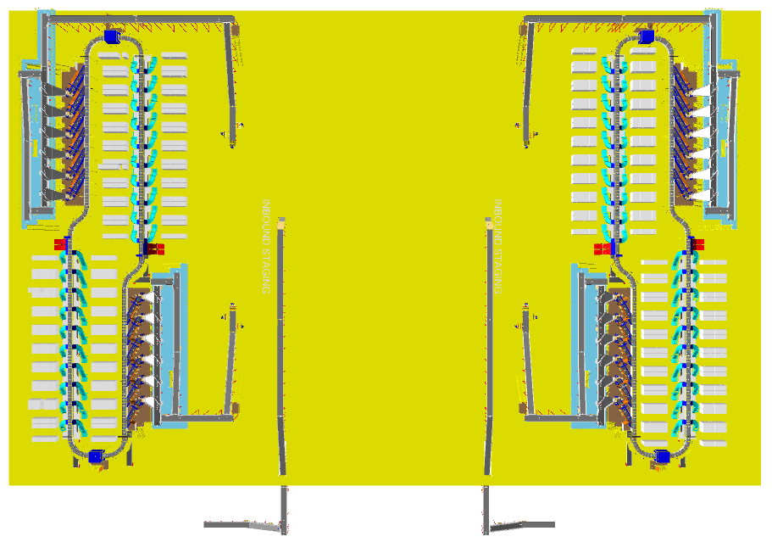
Layout View
2
1
5
2
4
3
6
2
3
4
7
6
5
6
3
1
2
3
6
7
8

4
4

Legend
1 – Bag Conveyor
2 – Infeed lines
3 – VDS system
4 – Induct lines
5 – Main CBS loop
6 – Secondary chutes (L-type)
7 – Rejection chutes (red colour)
8 – Mezzanine

Proposed System Capacity Calculations

Sorter System Capacity
The following table shows the throughput calculation for the sortation system designed based on Flipkart RFP requirements.

SPECIFICATION | VALUE
Sorter Type | Loop CBS
Speed | 2.1 m/s
Pitch | 600 mm
Carrier per hour | 12,600 CPH
Belts per hour | 12,600 BPH
Effective Designed Throughput of 1 loop CBS (A) | 25,200 Shipments per hour
Per Feedline Capacity | 2,000 Shipments per hour
No of Feedlines (Both Zones) | 12 Nos.
Total Feedline designed capacity (B) | 24,000 Shipments per hour
System designed throughput (Lower of A&B) | 24,000 Shipments per hour
Designed throughput from two loops | 48,000 Shipments per hour

System description

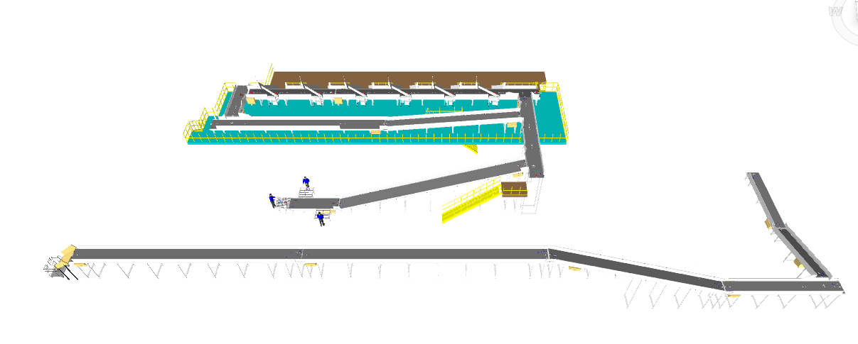
Infeed System
3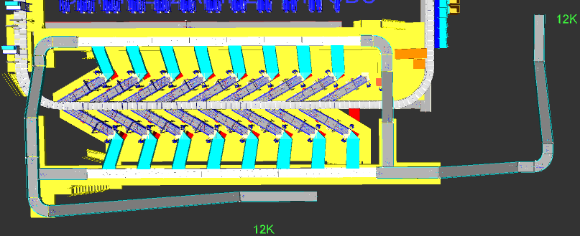
2
1
4

Legend
- Bag conveyor
- VDS Infeed Conveyor
- VDS Loop
- VDS Chutes

Every CBS loop is equipped with a bag conveyor, facilitating the movement of bags from the lower level to the mezzanine level. Additionally, each loop features two VDS infeed conveyors for transporting bulk shipments from the mezzanine level into the VDS loop.

Infeed System
Infeed conveyor system consists of below components:
- Straight PVC Conveyor
- Inclined PVC Conveyor
- Idler Roller Conveyor
- VDS System (Arm based/ Tilted Belt)
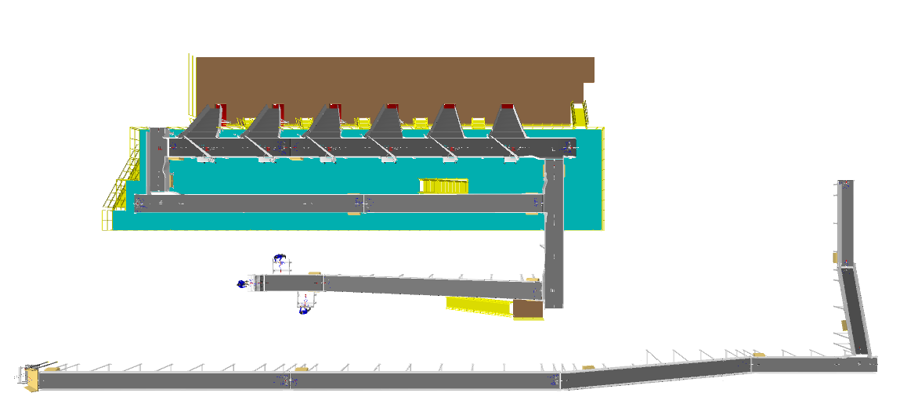
- VDS Chute
1
5
4
2
3
1
1
2
2

Straight and Inclined Powered Belt Conveyor

Falcon’s Belt Conveyors are modular & robust in design, used for smooth conveying of products over Straight, inclined and declined paths. MS profile is used to build conveyor frame.

The conveyors are supplied with the necessary supports and bolts to fix them to the supporting plane, as well as with the junction elements allowing easy and jam-free passage from one conveyor to the other.
Some Silent Features of Falcon’s Belt conveyor:
- Low Noise
- Maximum uptime.
- Minimal maintenance
- High safety standards.
- Fastest ROI.
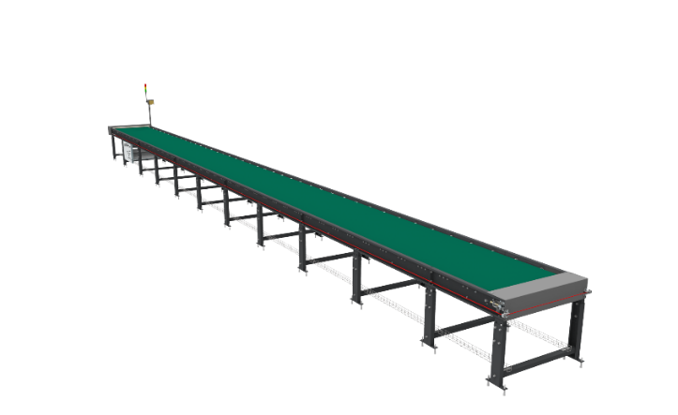

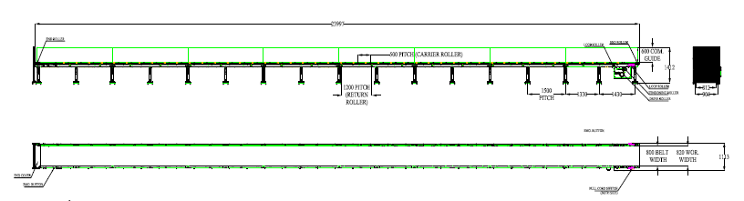

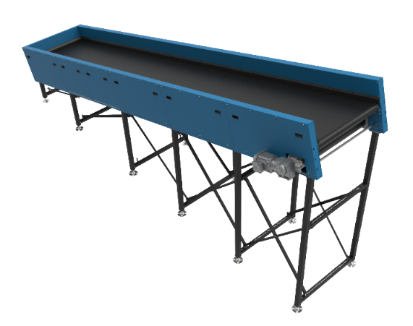
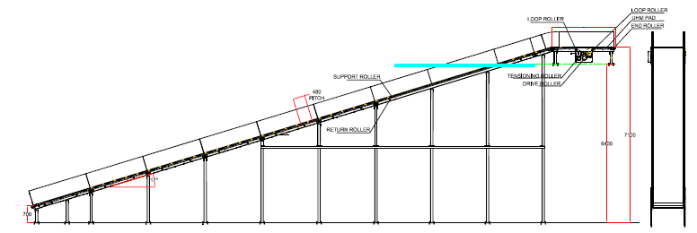

Specification | UOM | Remark
Manufacturer Name | Name | Falcon Autotech
Material of Roller | Type | MS Rollers with Zinc Plating
MOC of Belt | Type | PVC
Belt Thickness | mm | 3
Belt Finish | Type | Matt Finish
Belt width | mm | 1200
Belt Joint Type | Type | Vulcanized, Endless Belts
Belt Make/Model No. | Make | FORBO/DERCO
Chassis | mm | MS, 3mm Thick, Powder Coated-75 Microns
Idler Roller Pitch on running side (Top) | mm | 480
Idler Roller Specs | Spec | Dia.50.8, shaft-12 mm, bearing-6301
End Rollers | Spec | Dia 81.2 x 2.85 Thick, 30mm Shaft Dia, & Bearing Size-UCFH206D1, MOC-EN9, Zinc Plated -25 microns
Drive Rollers | Spec | OUTER Dia 178 PIPE Dia 168x5 Thick, 40mm Shaft Dia, & Bearing Size-UCF208D1, MOC(SHAFT)-EN9, NEOPRENE RUBBER COATING
Motor Shaft | MOC | EN9 Shaft material
Conveyor Under guarding | Spec | MOC-MS, 0.8 to 1mm thickness, Steel Stiffeners at every 600mm to avoid the sagging due to self-weight
Load capacity per unit length of Conveyor | kg/m | 50
Type of Guides | Type | Steel guides at 50mm/400mm height basis the position of conveyor on both sides from Conveyor Belt Surface.
Drive Power Rating | kW | Motor Rating depends on Length of the Conveyor
Type of Motor | Type | AC Geared Motor
Ingress Protection | Type | IP 55
Type of Drive System | Type | Direct Shaft Mounted Motor/ Flange Mounted
Type of Drive | Type | Chain drive/Torque Arm type
Gear Motor | make | Sew/Nord
Drive | make | Lenze/Siemens/Omron/Allen Bradly
Insulation Class | Type | Yes
Conveyor Speed | m/s | Variable speed to meet TPH requirements
Type of Mounts | Type | Fixed Heights Legs with Grouting Provisions

Sliding Type Chutes

A Sliding chute is a type of chute used for the smooth descent of materials or objects from an elevated position to a lower level & get collected in roll cage trolley (In FK Scope) placed below.
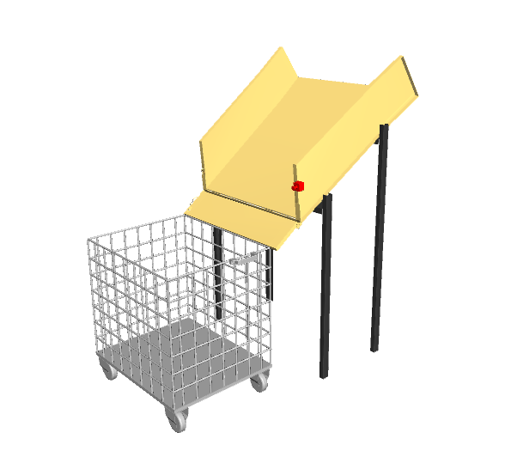
Bags coming from lower level to Mezzanine level via conveyor automation is guided by this chute & collected in the trolley below.

Idler Roller Conveyor
Falcon’s Roller conveyors require negligible maintenance leading to very minimal Operating costs and thus lower cost of ownership.
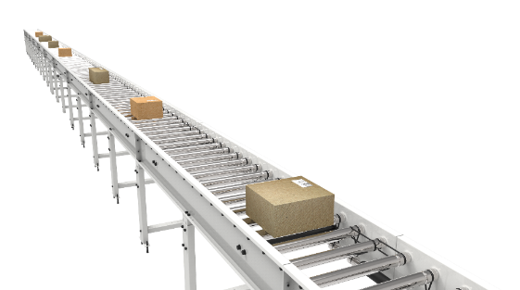
Some Salient Features of Falcon’s idler roller conveyor:
- Low Noise
- Maximum uptime.
- Minimal maintenance
- Comes with MS frame.

Specification | UOM | Remark
Manufacturer Name | Name | Falcon Autotech
Material of Roller | Type | MS Rollers with Zinc Plating
Overall Width | mm | 1000
Conveyor Height | mm | As per Layout requirement
Load capacity per unit length of Conveyor | kg/m | 50
Roller Span | mm | approx. 600
Roller Diameter | mm | approx. 50
Type of Mounts | Type | Fixed Heights Legs with Grouting Provisions
Type of Guides | Type | Yes
End Stopper | yes/no | Yes

Plastic Modular Belt Conveyor

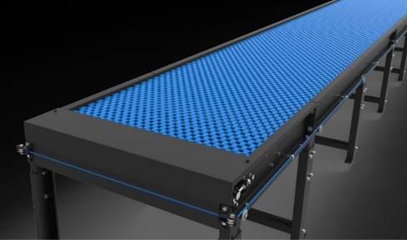
Falcon’s Belt Conveyors are modular & robust in design. MS profile is used to build conveyor frame.
Some Salient Features of Falcon’s Modular Belt conveyor:
- Low Noise
- Maximum uptime.
- Minimal maintenance
- High safety standards.
- Fastest ROI.
Specification | UOM | Remark
Manufacturer Name | Name | Falcon Autotech
Plastic Modular Belt Material | Type | POM with PBT Pins, Pitch-25.4 mm, Pin Dia- 5mm
Plastic modular Belt Make | Make | Movex
Sprocket Size & No. of Sprockets on Drive End & Tail End | Type | 5/146.4 mm
Sprocket material | MOC | POM
Chassis | mm | MS, 3mm Thick, Powder Coated-75 Microns
Wear Strip Material | MOC | UHMW PE1000
Return Roller type | Type | DIA- 50 mm/20303
Return Roller Pitch | mm | 800
Driven Shaft | Type | MOC-EN9 Solid Shaft hardened to BHN 240, Size-60SQ MM, Zinc Plated -25 microns, Bearings-UCF-210D1
Duplex Sprocket | MOC | MS
Duplex Chain | MOC | MS
Conveyor Under guarding | Type | GI SHEET (1MM THICK)
Type of Guides | Type | Steel guides at 50mm/400mm height basis the position of conveyor on both sides from Conveyor Belt Surface.

Diverter ARM

Linear Side Arm diverter System of Falcon AutoTech is an extremely cost-effective Sortation system designed for low to medium Volume Centres. Linear side arm diverter’s simple and modular design gives it advantage of low cost, space saving, and modularity of increasing sorting points in future. This is one of the earliest diverter systems of Falcon AutoTech.
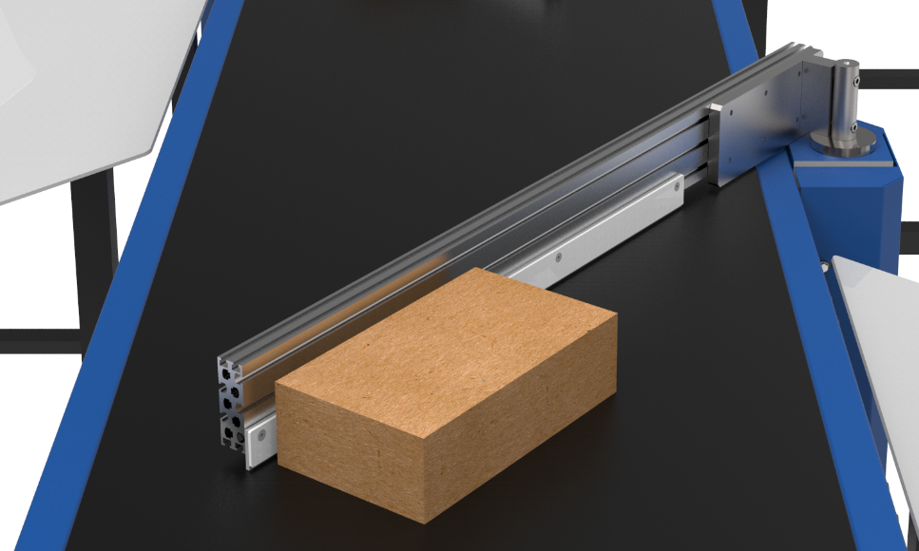

Specification | 3.0 ARM XL
Property | Value
Actuation method | Electric induction motor
Belt type | Flat top modular
Belt width (mm) | 1200
Arm length (mm) | 2400
Max. product size(LXWXH)(mm) | 600X400X300
Min. product size(LXWXH)(mm) | 100X100X5
Max. product weight (kg) | 40

Tilted Belt VDS

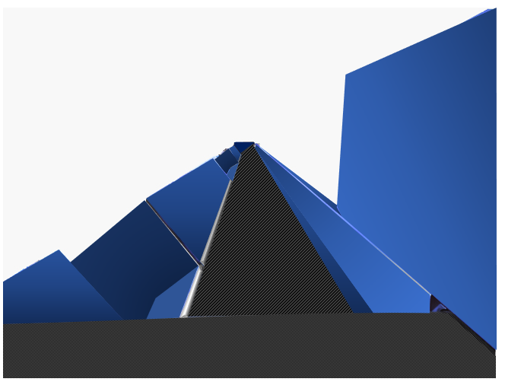

Specification | 3.0 ARM XL
Actuation method | Electric induction motor
Belt type | Tilted modular top
Belt width (mm) | 1200
Max. product size(LXWXH)(mm) | 600X400X300
Min. product size(LXWXH)(mm) | 100X100X5
Max. product weight (kg) | 40

Pros & Cones of ARM & Tilted Belt VDS System

 | ARM VDS | Tilted Belt VDS
Advantages | Positive discharge | Positive Blocking
 | Economical | All type of Parcels can Pass
 | Ease of maintenance
Disadvantage | Negative blocking | Negative discharge
 | Small parcel may stuck | Light Parcels might be stuck on belt itself
 |  | Parcel might remain on the conveyor Guides

VDS Chutes

A VDS chute is a type of chute used for the smooth descent of materials or objects from an elevated position to a lower level (at an operator level). It utilizes base metal to guide and support the flow of items along the chute & collect the shipments within its area.
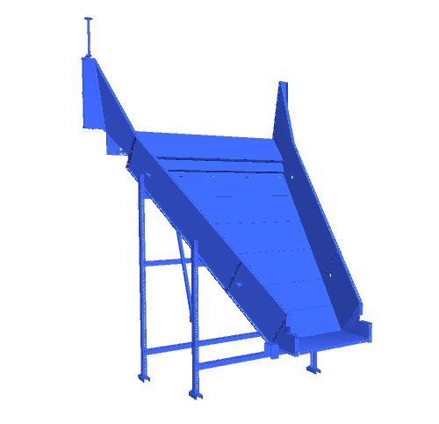
Calculation for Design: We have considered an average parcel size of 300 X 300 X 300 mm while designing the capacity of chutes.
Average parcel size considered for chute volume calculation | L(m) | B(m) | H(m) | Volume (m3)
 | 0.3 | 0.3 | 0.3 | 0.027
Collection type Chute | 3.3 | 1.5 | 0.4 | 2.07

Assuming a 60% occupancy rate, about 45 parcels will readily fit into these chutes.
Each Chute is equipped with below components to ease the operations:
- Chute Full Sensor
- Tower Light
Chute I/Os | Description
Chute Full Sensor | To alert the system that the chute is full and mark that chute unavailable for further sortation
Tower Lamp | To indicate the chute status
Push Button | To Start/Stop Sorting Operations
- Push Button

Conveyor BOQ

S No. | Name | EL_1 | EL_2 | Length(m) | Width (mm) | Set
1 | Powered Belt Conveyor | NA | NA | 4.32 | 1210 | 1
2 | Powered Belt Conveyor | NA | NA | 7.2 | 1210 | 1
3 | Powered Belt Conveyor | NA | NA | 10.08 | 1210 | 1
4 | Powered Belt Conveyor | NA | NA | 19.68 | 1210 | 1
5 | Powered Belt Conveyor | NA | NA | 18.24 | 1210 | 1
6 | Powered Belt Conveyor | NA | NA | 7.2 | 1210 | 1
7 | Powered Belt Conveyor | NA | NA | 10.56 | 1210 | 1
8 | Powered Belt Conveyor | NA | NA | 4.32 | 1210 | 1
9 | Powered Belt Conveyor | NA | NA | 4.32 | 1210 | 1
10 | Powered Belt Conveyor | 9760 | 9760 | 15.84 | 1210 | 1
11 | Powered Belt Conveyor | NA | NA | 4.32 | 1210 | 1
12 | Powered Belt Conveyor | 9760 | 9760 | 15.84 | 1210 | 1
13 | Powered Belt Conveyor | 10510 | 10510 | 14.4 | 1210 | 1
14 | Powered Belt Conveyor | NA | NA | 19.68 | 1210 | 1
15 | Powered Belt Conveyor | NA | NA | 4.32 | 1210 | 1
16 | Powered Belt Conveyor | 9760 | 9760 | 15.84 | 1210 | 1
17 | Powered Belt Conveyor | NA | NA | 4.32 | 1210 | 1
18 | Powered Belt Conveyor | 9760 | 9760 | 15.84 | 1210 | 1
19 | Powered Belt Conveyor | NA | NA | 17.28 | 1210 | 1
20 | Powered Belt Conveyor | NA | NA | 4.32 | 1210 | 1
21 | Powered Belt Conveyor | NA | NA | 10.56 | 1210 | 1
22 | Powered Belt Conveyor | NA | NA | 7.2 | 1210 | 1
23 | Powered Belt Conveyor | NA | NA | 4.32 | 1210 | 1
24 | Powered Belt Conveyor | NA | NA | 17.28 | 1210 | 1
25 | Powered Belt Conveyor | NA | NA | 19.68 | 1210 | 1
26 | Powered Belt Conveyor | NA | NA | 19.68 | 1210 | 1
27 | Powered Belt Conveyor | NA | NA | 10.08 | 1210 | 1
28 | Powered Belt Conveyor | NA | NA | 9.6 | 1210 | 1
29 | Powered Belt Conveyor | NA | NA | 18.24 | 1210 | 1
30 | Powered Belt Conveyor | 10510 | 10510 | 14.4 | 1210 | 1
31 | Powered Belt Conveyor | 701 | 2933 | 7.173 | 1210 | 1
32 | Powered Belt Conveyor | 2601 | 7779 | 16.706 | 1210 | 1
33 | Powered Belt Conveyor | 5601 | 10743 | 16.59 | 1210 | 1
34 | Powered Belt Conveyor | 5802 | 10746 | 15.95 | 1210 | 1
35 | Powered Belt Conveyor | 9650 | 10804 | 12.32 | 1210 | 1
36 | Powered Belt Conveyor | 9650 | 10804 | 12.32 | 1210 | 1
37 | Powered Belt Conveyor | 9650 | 10804 | 12.32 | 1210 | 1
38 | Powered Belt Conveyor | 9650 | 10804 | 12.32 | 1210 | 1
39 | Powered Belt Conveyor | 5802 | 10746 | 15.95 | 1210 | 1
40 | Powered Belt Conveyor | 2601 | 7779 | 16.706 | 1210 | 1
41 | Powered Belt Conveyor | 701 | 2933 | 7.173 | 1210 | 1
42 | Powered Belt Conveyor | 5601 | 10743 | 16.59 | 1210 | 1
43 | Gravity Roller Conveyor | 5850 | 5750 | 1.22 | 1200 | 1
44 | Gravity Roller Conveyor | 5850 | 5750 | 1.22 | 1200 | 1
45 | Gravity Roller Conveyor | 5850 | 5750 | 1.22 | 1200 | 1
46 | Gravity Roller Conveyor | 5850 | 5750 | 1.22 | 1200 | 1
47 | Gravity Roller Conveyor | 5850 | 5750 | 1.22 | 1200 | 1
48 | Gravity Roller Conveyor | 5850 | 5750 | 1.22 | 1200 | 1
49 | Gravity Roller Conveyor | 5850 | 5750 | 1.22 | 1200 | 1
50 | Gravity Roller Conveyor | 5850 | 5750 | 1.22 | 1200 | 1
51 | Gravity Roller Conveyor | 5850 | 5750 | 1.22 | 1200 | 1
52 | Gravity Roller Conveyor | 5850 | 5750 | 1.22 | 1200 | 1
53 | Gravity Roller Conveyor | 5850 | 5750 | 1.22 | 1200 | 1
54 | Gravity Roller Conveyor | 5850 | 5750 | 1.22 | 1200 | 1

Induction to Sorter
The main purpose of the feedlines is to transport the shipments from the infeed points to the sorter by means of straight and curved belt conveyors, 30° merging conveyors, roller aligner conveyors and 30° induction lines. The flow of shipments on the belt conveyors is controlled by sensors in such a way that a gap is ensured between the shipments.
After the entry points to the unloading areas, all feed lines rise above the ground on mezzanine, leaving a working area underneath. The inclination of the belt conveyors towards the sorter will be maximized to obtain the best possible use of the space below the sorting loop. Shipment slippage will be prevented by using a maximum tilt angle of 15°.
Scales installed on the feedlines will acquire the weight of each shipment and will perform weight control to detect out-of-spectrum shipments.
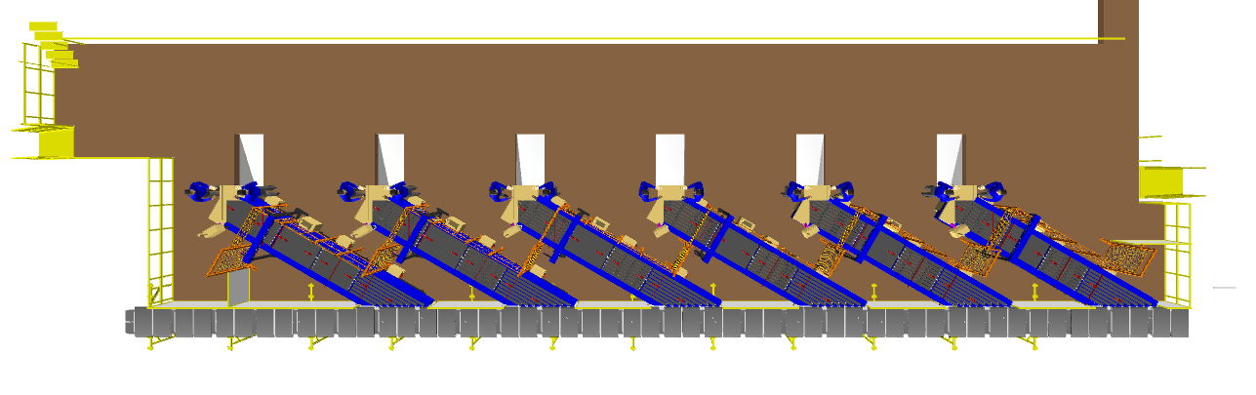
In order to minimize the number of infeed lines while respecting the necessary flow rates for all unloading areas, the flows from the unloading stations will be merged, taking into account the maximum flow rate of each injector. Thus, the system's design ensures that the maximum capacity of each feed, considered as the sum of the flows from the connected inductions, is always less than the planned induction capacity of 2000 shipmen ts/hour.

Induction Zone

Feedlines
Each Loop CBS has a total 12 Automatic Feedlines with Designed IPP of 2000 PPH.

- Each Feedline has Four Conveyor Modules-

  - Orientation Conveyor- 1 Nos.
  - Weighing Conveyor- 1 Nos.
  - Buffer conveyor- 1 Nos.
  - Intelligent Merge- 1 Nos.

- Sensors are placed on the Induct Lines to determine the exact position and dimensions (Length and Width) of the Shipment on the conveyor and prepare the Cross-Belt Cell for receiving the shipment with high precision.

- Over the feedline, shipments are evenly spaced and smoothly transferred to the main Loop.

Buffer Conveyors
A buffer conveyor, also known as a buffering conveyor or accumulation conveyor, is a type of conveyor system used to temporarily store or hold items in a controlled manner. Its primary purpose is to manage the flow of items between different stages of a production or handling process when there is a mismatch in the speeds or capacities of the upstream and downstream equipment.
This Conveyors required to maintain the Throughput of Line.
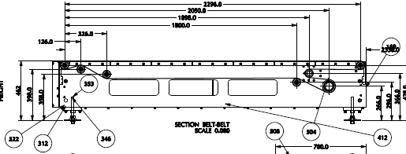
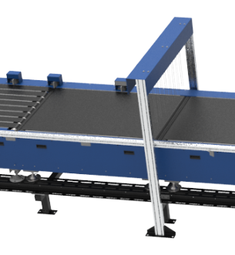

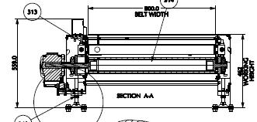

Weighing Conveyor
A weighing conveyor, also known as a weigh belt conveyor, is a type of conveyor system specifically designed to measure the weight of materials as they move along the conveyor belt. It combines the functions of conveying and weighing into a single integrated process.
Weighing Conveyors equipped with high precision Load Cells to capture the weight of Shipments.
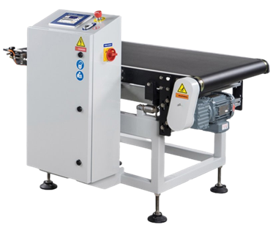
Make- Bizerba/ Mettler Toledo

Orientation Conveyor
An Orientation conveyor is a type of conveyor system used to align & Release the products for induction onto CBS. It serves as the initial point of entry where products are collected and conveyed to subsequent stages of the process.
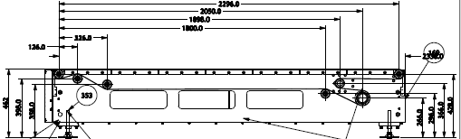

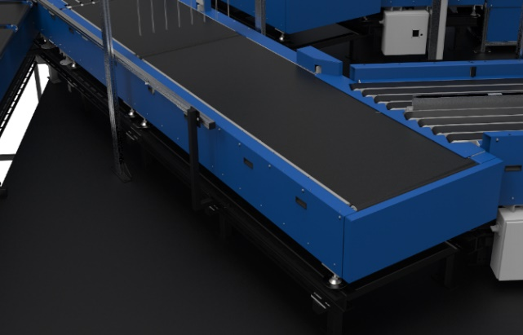

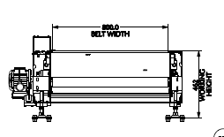

Intelligent Merge Conveyor
An intelligent merge conveyor is a type of conveyor system that incorporates advanced automation and control technologies to intelligently merge multiple conveyor lines or streams of materials into a single unified flow. It optimizes the merging process by dynamically adjusting the speed and position of items to ensure a smooth and efficient merge.
In the proposed solution this is 30° triangular high-speed conveyor used for inducting shipment/boxes directly on to the sorter. The Belts are Strip Belts for smooth shipment movement.
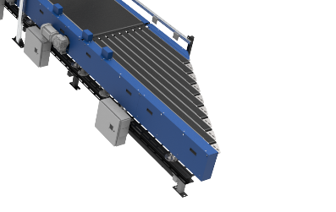
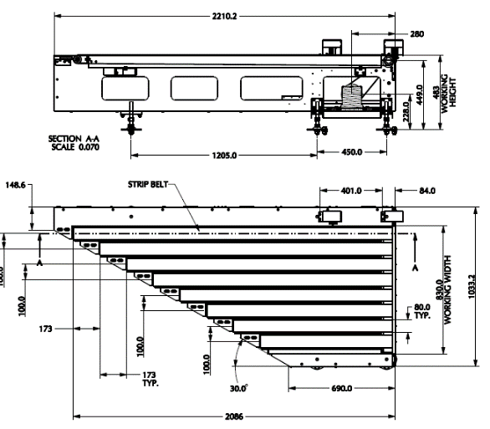

New Induct Fencing

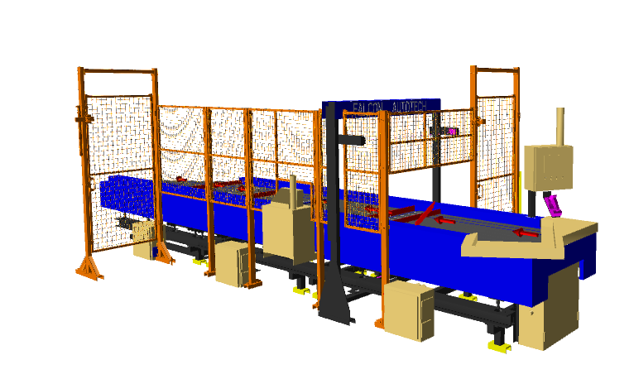
Setting a new Safety paramount. The new Induct Fencing helps prevent unauthorized operators from entering the induction zone, eliminating the risk of accidents and injuries.

Irregular Takeout Conveyor
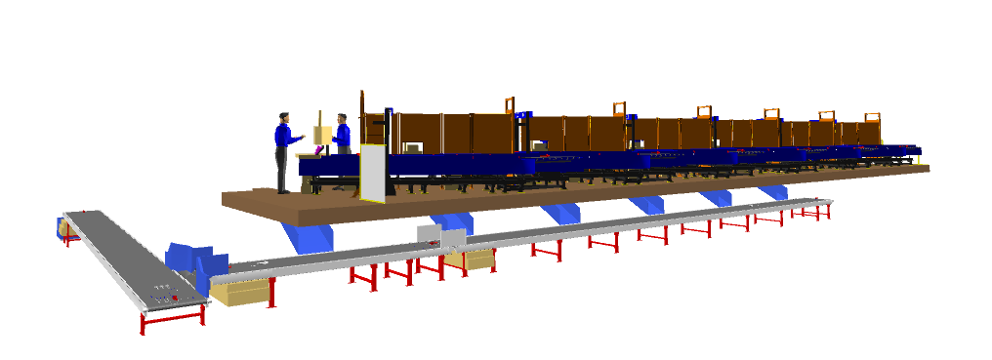

Irregular Chute


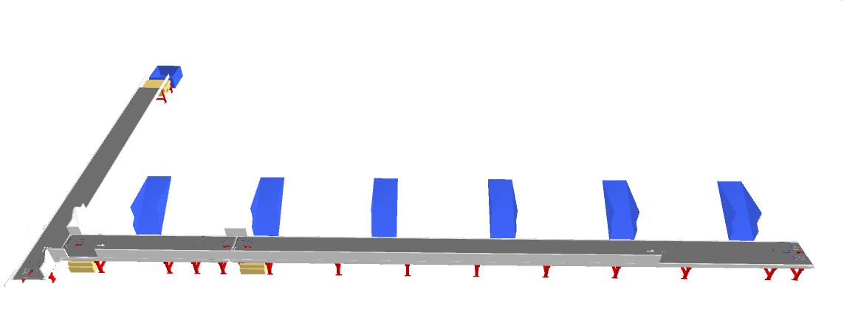

Irregular Takeaway Conveyor
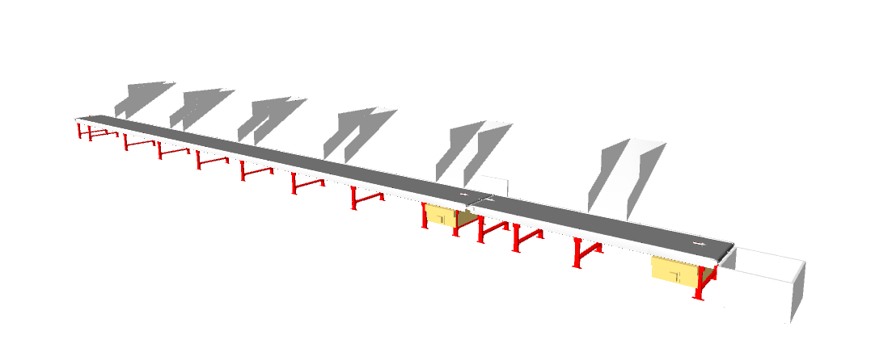

Irregular Collection Bin (In Flipkart’s scope)
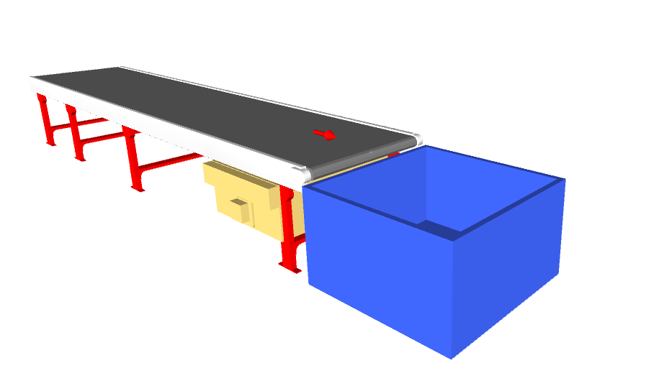

Conveyor BOQ

S No. | Name | EL_1 | EL_2 | Length(m) | Width (mm) | Set
1 | Powered Belt Conveyor | NA | NA | 19.68 | 1010 | 1
2 | Powered Belt Conveyor | NA | NA | 10.08 | 1010 | 1
3 | Powered Belt Conveyor | NA | NA | 10.56 | 1010 | 1
4 | Powered Belt Conveyor | NA | NA | 12.48 | 1010 | 1
5 | Powered Belt Conveyor | NA | NA | 19.68 | 1010 | 1
6 | Powered Belt Conveyor | NA | NA | 12.48 | 1010 | 1
7 | Powered Belt Conveyor | NA | NA | 5.76 | 1010 | 1
8 | Powered Belt Conveyor | NA | NA | 19.68 | 1010 | 1
9 | Powered Belt Conveyor | NA | NA | 19.68 | 1010 | 1
10 | Powered Belt Conveyor | NA | NA | 5.76 | 1010 | 1

Main Loop
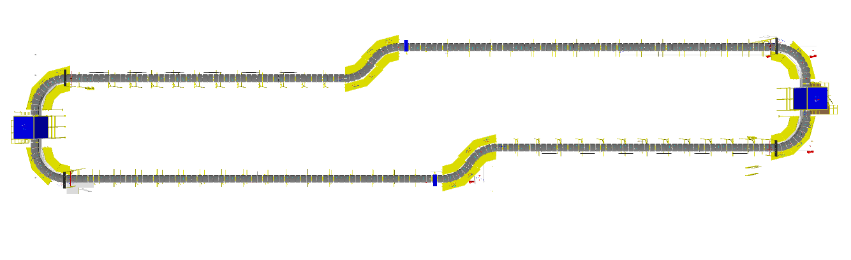
Induct Zone

Induct Zone

- The proposed Single Deck CBS Sorter will be installed on ground level. The Sorter runs at 3000 mm from ground level.

- We have provided loop with Single Belt Carriers with 600 mm pitch and Belt Size of 495 x 800mm.

- One loop CBS has a total length of 188 m & 314 number of carriers.

- As Shipments pass through the Barcode Scanning Tunnel on the Loop, their barcodes are scanned, and chutes are assigned. Once the shipment reaches the respective chute, the carrier carrying the shipment for the chute will actuate and drop the shipment in the assigned chute.

Sorting Output

L-Type Collection chute
A collection chute is a type of chute used for the smooth descent of materials or objects from an elevated position to a lower level. It utilizes base metal to guide and support the flow of items along the chute & collect the shipments within its area.
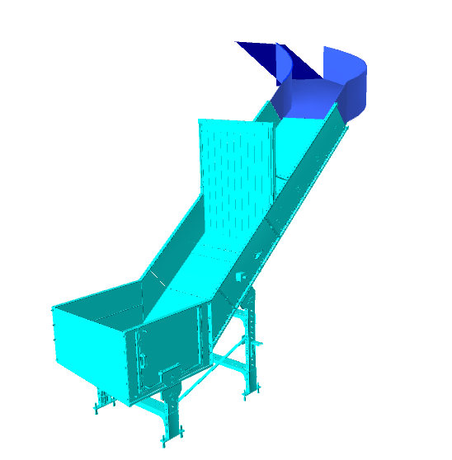
Each collection type chute has capacity to accumulate 30 shipments, The sorted shipments will travel along these collection chutes and get accumulated at the bottom of the chute.

Calculation for Design: We have considered an average shipment size of 300 X 300 X 300 mm while designing the capacity of chutes.
Average shipment size considered for chute volume calculation | L(m) | B(m) | H(m) | Volume (m3)
 | 0.3 | 0.3 | 0.3 | 0.027
Collection type Chute | 4.1 | 0.8 | 0.4 | 1.312

Assuming a 60% occupancy rate, about 30 shipments will readily fit into these chutes.
Each Chute is equipped with below components to ease the operations:
- Chute Full Sensor
- Four Color Tower Light
- Push Button
Chute I/Os | Description
Chute Full Sensor | To alert the system that the chute is full and mark that chute unavailable for further sortation
Four Colour Tower Lamp | To indicate the chute status
Push Button | To Start/Stop Sorting Operations

Rejection Chute

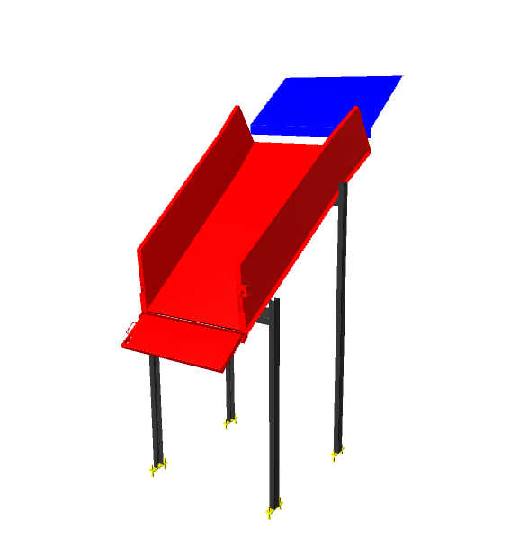
Rejection Chute is a type of chute used for the smooth descent of materials or objects from an elevated position to a lower level. It utilizes base metal to guide and support the flow of items along the chute & end gate can be closed to collect the shipments within its area.
Rejection chute has capacity to accumulate 16 shipments, The sorted shipments will travel along these collection chutes and get accumulated at the bottom of the chute if the end gate is closed.

Calculation for Design: We have considered an average shipment size of 300 X 300 X 300 mm while designing the capacity of chutes.
Average shipment size considered for chute volume calculation | L(m) | B(m) | H(m) | Volume (m3)
 | 0.3 | 0.3 | 0.3 | 0.027
Collection type PTL Chute | 2.0 | 0.9 | 0.4 | 0.72

Assuming a 60% occupancy rate, about 16 shipments will readily fit into these chutes.
Each Chute is equipped with below components to ease the operations:
- Chute Full Sensor
- Four Color Tower Light
- Push Button
Chute I/Os | Description
Chute Full Sensor | To alert the system that the chute is full and mark that chute unavailable for further sortation
Four Colour Tower Lamp | To indicate the chute status
Push Button | To Start/Stop Sorting Operations

Chute Safety Net

A safety measure is implemented by installing an overhead chute net between each chute to prevent parcels from falling from the CBS into the operator's workspace, thereby enhancing operator safety.
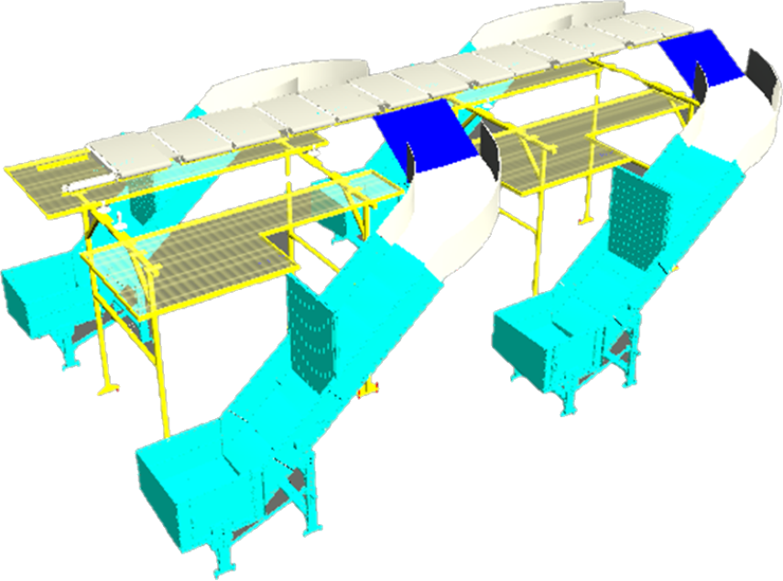

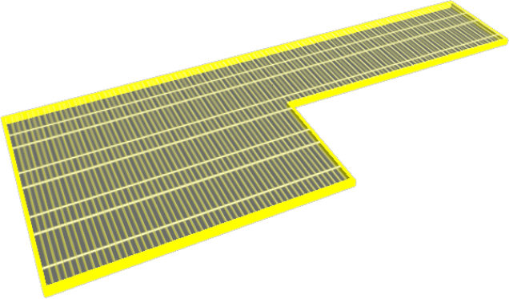

The overhead net has a width of 1300 mm and effectively spans the entire 2900 mm gap between two consecutive chutes.

Bag Take away Conveyor

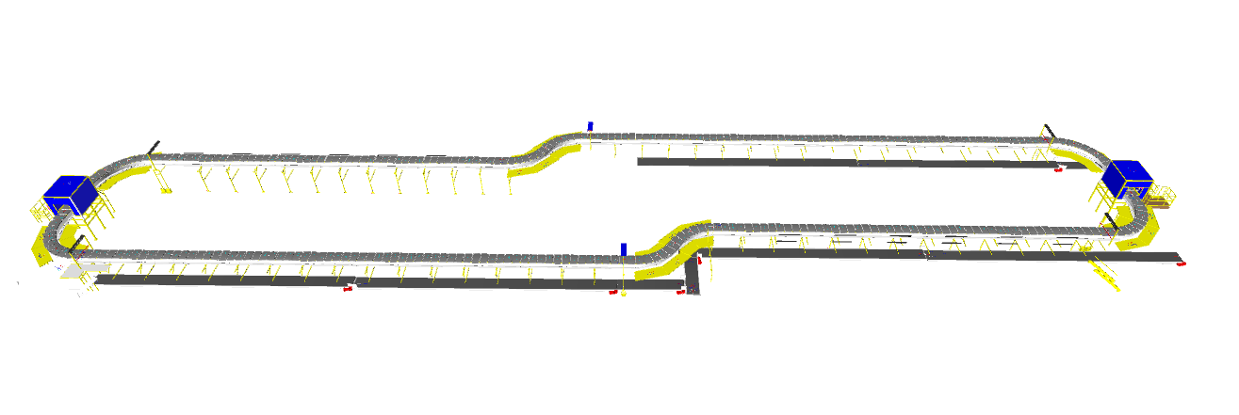
In each Loop CBS, there is a series of Bag Takeaway Conveyors, spanning a combined length of 262 meters. Following the secondary sorting process, bags are securely fastened and manually placed onto these conveyors, which are positioned below the Loop CBS to cover all chute locations. These conveyors then transport the collected bags back to the lower level.

Conveyor BOQ

S No. | Name | EL_1 | EL_2 | Length(m) | Width (mm) | Set
1 | Bagging Conveyor | 5493 | 5593 | 19.94 | 1210 | 1
2 | Bagging Conveyor | 5473 | 5573 | 5.06 | 1210 | 1
3 | Bagging Conveyor | 5500 | 5600 | 19.94 | 1210 | 1
4 | Bagging Conveyor | 5538 | 5638 | 3.6 | 1210 | 1
5 | Bagging Conveyor | 5482 | 5582 | 19.94 | 1210 | 1
6 | Bagging Conveyor | 5483 | 5583 | 18.02 | 1210 | 1
7 | Bagging Conveyor | 5500 | 5600 | 19.94 | 1210 | 1
8 | Bagging Conveyor | 5600 | 5700 | 5.06 | 1210 | 1
9 | Bagging Conveyor | 5482 | 5582 | 19.46 | 1210 | 1
10 | Bagging Conveyor | 5482 | 5582 | 19.94 | 1210 | 1
11 | Bagging Conveyor | 5538 | 5638 | 3.6 | 1210 | 1
12 | Bagging Conveyor | 5500 | 5600 | 19.94 | 1210 | 1
13 | Bagging Conveyor | 5473 | 5573 | 5.06 | 1210 | 1
14 | Bagging Conveyor | 5493 | 5593 | 19.94 | 1210 | 1
15 | Bagging Conveyor | 5482 | 5582 | 19.46 | 1210 | 1
16 | Bagging Conveyor | 5600 | 5700 | 5.06 | 1210 | 1
17 | Bagging Conveyor | 5500 | 5600 | 19.94 | 1210 | 1
18 | Bagging Conveyor | 5483 | 5583 | 18.02 | 1210 | 1

Description of Components of Equipment

Elements of the sorting system
- Cross Belt Sorter
- Scanning & Sensing on Sorter
- Conveyor System
- Steel Works- Mezzanine & Staircases

Cross Belt Sorter -

Cross Belt Sorter is capable of sorting extremely high volume of versatile products in a gentle manner.
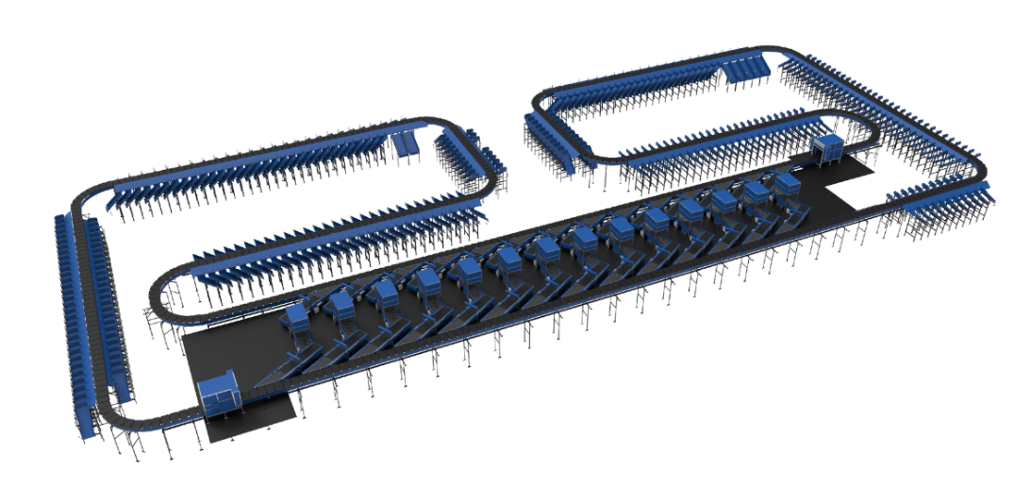
Falcon’s Cross belt sorter is powered by high efficiency linear motors and is based on 100% non-touch actuation technology leading throughput capabilities with extremely low noise levels.
Falcon’s Cross belt sorter is modular in design. It can be easily extendable as per future requirements

CBS Carrier

Falcon’s CBS offers one of the highest Belt widths to Carrier Pitch Ratio in the market today. This additional belt width makes the system capable of handling larger product sizes without compromising on throughput. This also means reduced “dead area” between Carrier belts which drastically reduces the amount of “inbetweeners “and non-sortable shipment recirculation.

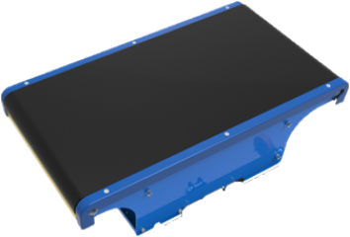

Servo Roller

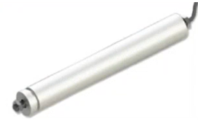
High Powered DC Drive Servo Roller are used to actuate the carrier belts, thereby eliminating the need for complicated drive transfer mechanism, and simplifying the system installation and maintenance.

Chassis

Falcon Autotech’s Cross Belt Carrier Chassis is made up of lightweight Aluminium which makes them light yet sturdy. This reduced weight leads to substantial “Power Savings” over a considerable period of usage.

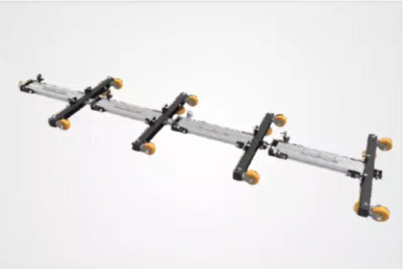

Carrier Wheels

Carrier wheels that are thoroughly tested and proved for long life cycle.

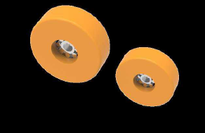

Motor Drives
Falcon offers a choice between two motor drive technology options.

Friction Wheel Drive
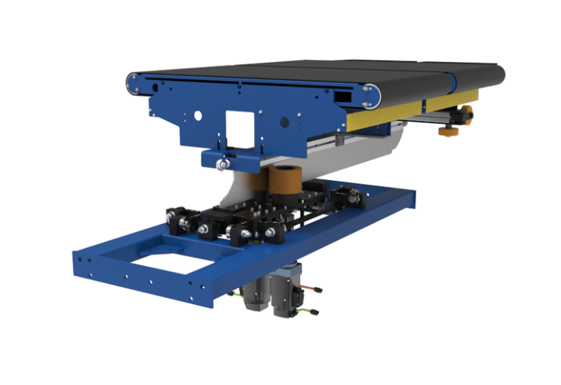
Extremely High Energy Efficient FWD that can be configured at variable speeds depending upon the operational requirements giving you the maximum flexibility when needed. Using servo motors to power friction wheels, FWD makes it better in terms of controlled speed, acceleration & deceleration

Non-contact based linear motor drive
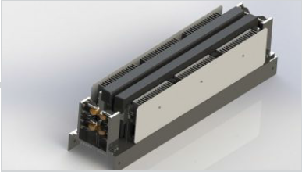
Extremely Energy Efficient Linear Induction Motors that can be configured at variable speeds depending upon the operational requirements giving you the maximum flexibility when needed.

Power Transmission
Power transmission to Carriers over sliding contacts that require low maintenance and offer high levels of reliability.
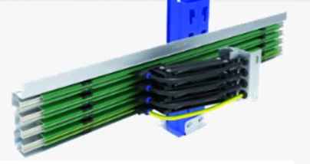

Data Transmission
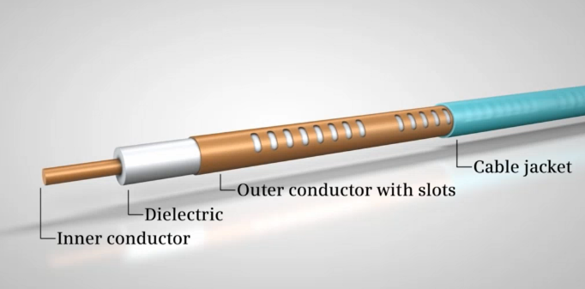
The R-Coax cable is used for data distribution in the sorter. This is a leaky wave cable, that runs throughout the sorter length transmitting the data. There is one antenna present in the super master carriage, which keeps on receiving the signal from this cable while on the move, wirelessly.
Leaky wave cable position
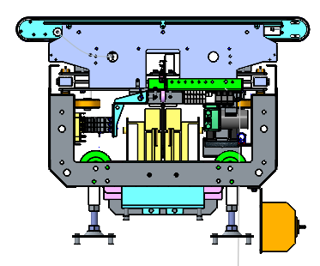

Carriers positioning System.
Positioning system determines the exact location of each carrier in the loop at any given point in time. There is a plastic tape strip of barcodes (QR Codes) that is running along the sorter loop, which is continuously scanned by scanners placed on a Carrier (Master Carrier)

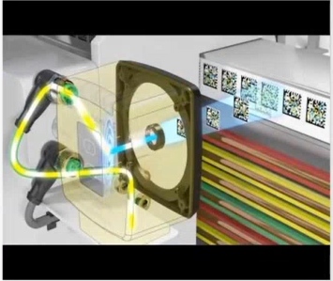

Technical specifications of Sorter

Items | Make
Sorter Carrier Type | Loop CBS
Sorter Speed in m/s | Up to 2.1 m/s
Sorter Loop Length | ~188 m
Sorter Actuation Technology | Electric
Chutes
Collection Chute | 40
Rejection Chute | 4
VDS Chute | 12
Irregular Chute | 12
Height of Sorter | ~3000 mm
Carrier Design
Carrier Motor Make | Falcon
Carrier Pitch - mm | 600
No. of Carriers | 314 Nos.
Drives
Motor/Drive type | Friction Wheel Drive
Power Consumption | Will be specified during DAP
Feedlines (Semi-Automatic) | 12 Nos
Power and Data Transmission
Power Transmission | Over Continuous Bus Bar
Empty Carrier Detection System (Camera Based) | 01 Nos
Maintenance Speed of the Sorter- Jog Mode | 0.8 m/s
Area Requirement (L x B) | Refer Layout

Scanning & Sensing on Main Sorter Loop

Automatic Barcode Scanning & Dimensioning System
Top Sided Barcode Scanner to scan shipment 1D codes and 2D codes. The Scanner is also capable of Archiving Shipment Images in Real time. As per FLIPKART requirements, Scanning is in FLIPKART scope.
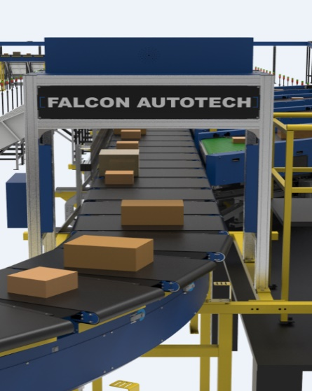
Falcon needs to supply Volume Measurement System. VMS 4200 quoted as option for Dimensioning of Shipments.

Shipment Positioning System.
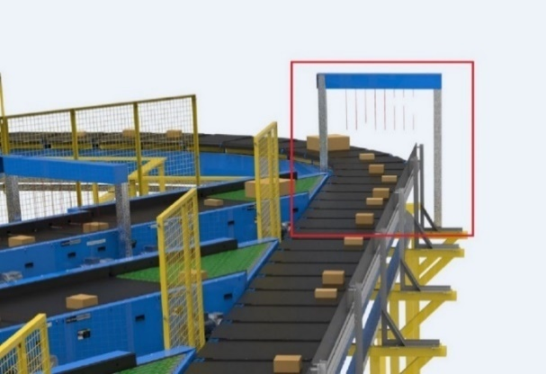
Falcon Cross Belt Sorter is equipped with Multiple shipment positioning Scan Tunnels. A tunnel comprises of a series of high Precision Laser Scanners that detect the absolute position of the Shipment on the Cross-Belt Carrier and prepares the Carrier for discharging the product accurately into the chute (virtual centring) and physically bring the product to the centre of cross belt carrier (Physical centring).

Empty Carrier Detection System
This system detects the empty carriers on the sorter and prepares the Feedlines to load the shipments on the empty carriers. (Camera based)
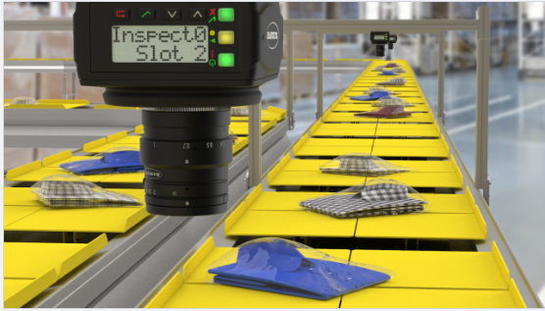

Steel Works – Mezzanine, Maintenance Platforms & Staircases-

Mezzanine
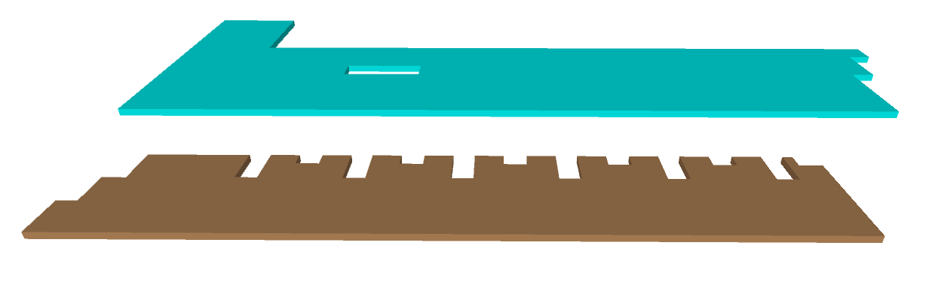

VDS Mezzanine

Induct Mezzanine

Plan view of Mezzanine

- Total Mezzanine Area: 1476 Sq. Metres
- Clear height below Mezzanine: 3700 mm
- No of Stairs: 50 Nos

Each CBS loop consist of:
- Total Mezzanine Area of Loop 1: 738 Sq. Metres
  - 2 Nos – Approx. 238 Sq. Meters of VDS Mezzanine
  - 2 Nos – Approx. 130 Sq. Meters of Induct Mezzanine
- Clear height below Mezzanine:
  - 3700mm below VDS Mezzanine
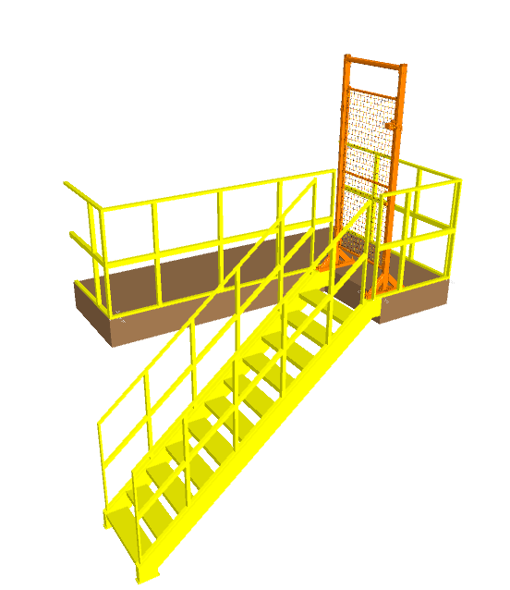
  - 1900mm below Induct Mezzanine

Maintenance Platform & Staircase

- 5 Sq. Meter: 02 Nos

Maintenance platform with lockable gate

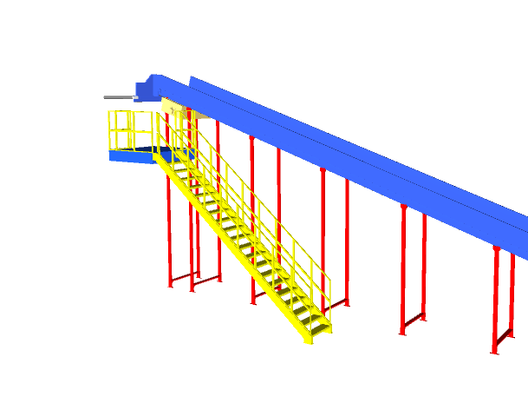
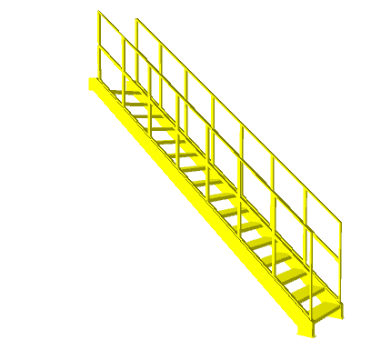

- 3 Sq. Meter: 02 Nos

Maintenance platform for conveyor above 3 meters

- No of Stairs: 25 Nos
Staircase View

Allocated Areas
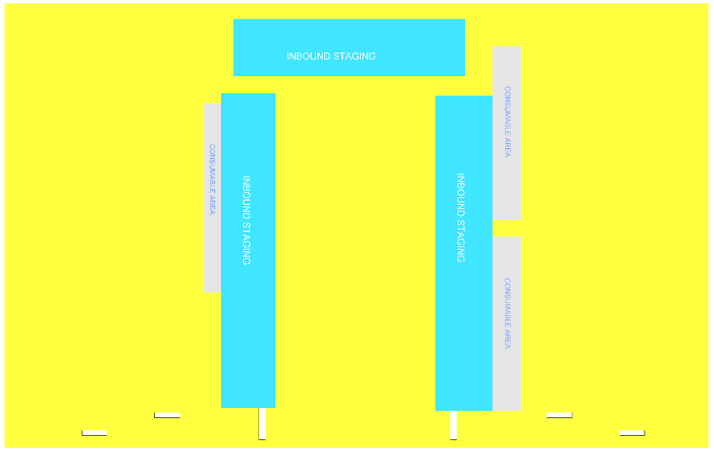
Output chute
Induct Zone
Induct Zone
Output chute
Output chute
Induct Zone
Induct Zone
Output chute

Plan View

System is marked with different type of Staging areas.
Inbound Staging Area – A total area of 2,347 Sq. Meter is dedicated for Inbound staging of Bags & Shipments.
Consumable Area – A total area of 649 Sq. Meter is dedicated for Consumables.
Note – The dedicated Areas are considered basis the specification shared by Flipkart.

Proposed System Technical Details (Two Loops)

Mechanical equipment

Pos. | Qty. | Description | Value
1 | 1 | Infeed System  - Powered Belt Conveyors  - Modular Belt Conveyor  - Idler Roller Conveyor  - XL ARM Diverters/Tilted VDS gates  - VDS Chutes | ~511 metres (42 Modules)  ~112 metres (8 Modules)  ~15 metres (12 Modules)  24 Nos  24 Nos
2 | 4 | Feedlines  Consists of  - Receiving Conveyor  - Weighing Conveyor  - Buffer Conveyor  - Intelligent merge | 1 Set  1 Set  1 Set  1 Set
3 | 1 | Irregular Shipment Handling  - Powered Belt Conveyors  - Irregular chutes | ~136 metres (10 Modules)  24 Nos
4 | 2 | Sorter  1 Loop Cross Belt Sorter  - Sorter Height  - Sorter Length  - Sorter Speed  - Sorter Drive  - Carrier Pitch  Including:  - Standard Sorter Supports  - Empty Carrier Detection System  - Product Centring System  - Dimension Scanning System  - E-Stops  - Hooters  - Fencing | 3000mm (from mezz level)  ~188 m  ~2.1 m/s  Linear Motor  600 mm
5 | 2 | Sorter Outputs  - L-Type Chute  - Rejection Chutes | 40 Nos  04 Nos
6 | 1 | Bag Takeaway Conveyor  - Powered Belt Conveyors | ~262 metres (18 Modules)
7 | 1 | Steel Works  - Operator and Maintenance Platform  - Stairs | ~1508 SQM  50 Nos

Electrical Equipment

Electricals
1 | 1 | Consists of  Main Power Distribution panel  Main Control Panel  Feedline Control Panels  Sorter Drive Panels  Network Switches  Field Cabling | Included

Control System

Components
1 | 1 | Consists of  Siemen’s PLC based Control System with SCADA  Industrial Switch | 1 Nos.  As per requirement

Electrical System
Main power supply will supply Falcon’s PDP (Power Distribution Panels) electrical cabinets.
PDP cabinets supply the entire system via secondary cabinets:
- Main Control Cabinet
- Induct Control Panels
- Remote Cabinets for Sorter I/O
- Scanner Control cabinets

Reference Picture of Power Distribution Panel
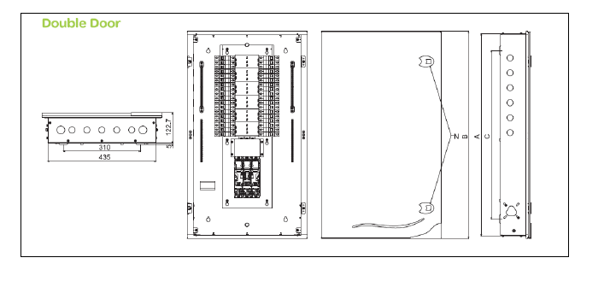

Main Control Panel (Reference)

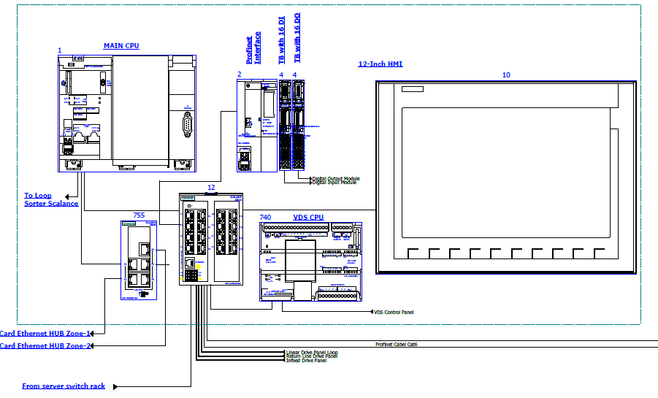

Induct Stations Control Panel (Reference)

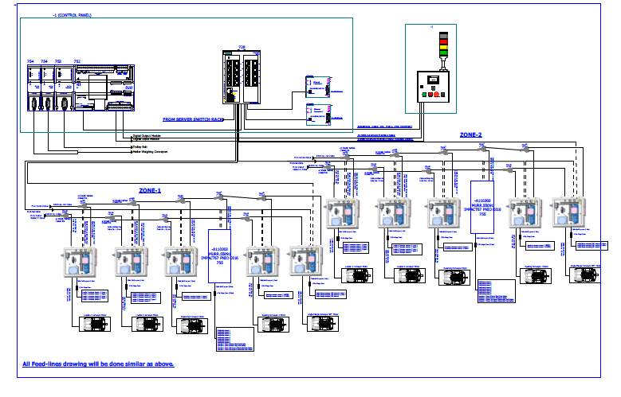

Engines
Three-phase alternating current motors (Induction) will be used through a frequency converter.
The engines will be coupled with a converter to improve consumption and reduce the carbon footprint.
All motors will have appropriate IP ratings

Sensors
The sensors will be supplied, standardized by type, with connector, with a cable length suitable for easy extraction, suitably protected from possible impacts.

Control command
The proposed solution is based on SIEMENS Programmable Logic Controller technology (PLC) platform. The entire system will be logically divided into Zones (Sorter/ Feed Line/ Loop), each managed by a PLC. The planned primary communication protocol is going to be ProfiNet.

Conveyor interface
The frequency converter of each conveyor allows the acquisition of the signals of the sensors/actuators/GIOs associated with it (e.g. conveyor end detection photocells, blockage detection photocells). Each frequency converter will be connected in series by means of the ProfiNet field bus

Controls Architecture (Ref.)

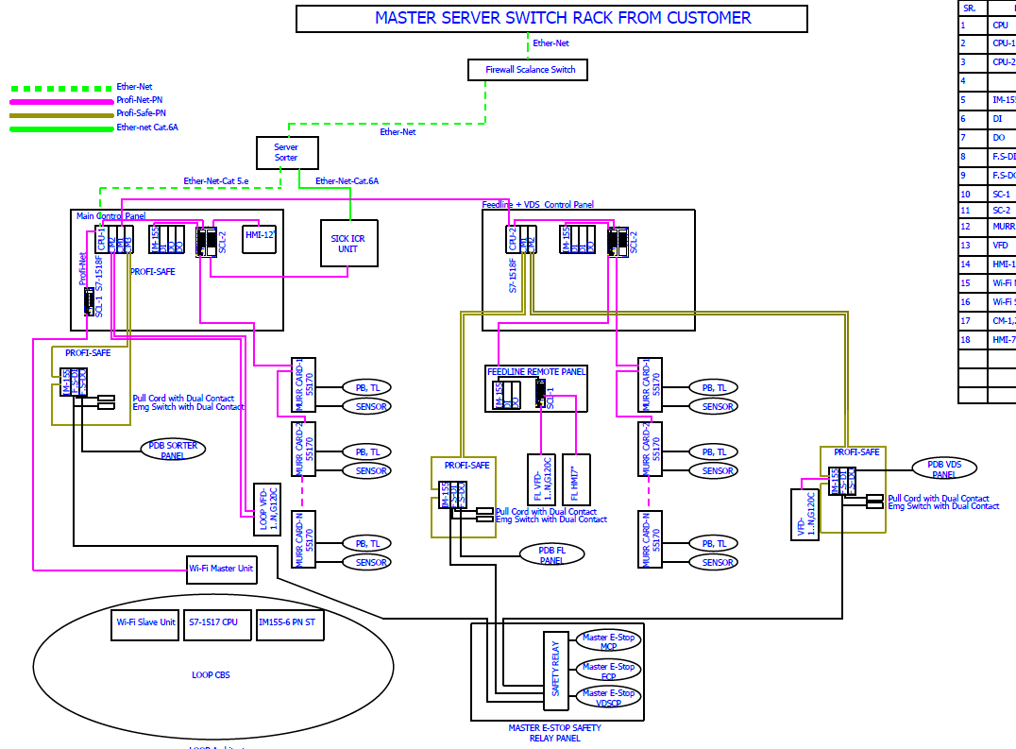

IT Architecture (Ref.)
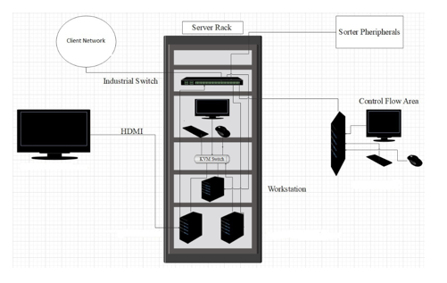

HAA Server (In Flipkart Scope)

S.no | Description | Qty
20Core Config with 128 GB RAM in T440 and 64 GB RAM in T40
1 | Synology_storage_DS723+ 2.6 GHz AMD Ryzen R1600 Dual-Core, 2 x Gigabit Ethernet Ports, | 2
 | 2GB ECC DDR4 RAM, 2 x 3.5/2.5" Bays | 2 x M.2 2280 Slots E10G22-T1-Mini 10GbE RJ-45 network upgrade module for compact Synology servers
2 | Dell Tower Model T440 -PowerEdge T440 Xeon Gold 6148 2.4GHz/20C/27.5MB/150 W 16 DIMMS 4 x32GB RDIMM Up to 8 3.5"" Hot Plug Hard Drives Tower Configuration 2 x 1.2TB 10K RPM SAS 12Gbps 512n 2.5in | 2
 | Hot-plug Hard Drive PERC H750 Adapter Full Height 8GB Cache Dual Hot-plug PS495W iDRAC9Enterprise 3YR ProSupport Next Business Day Onsite/Dual Port Lan
3 | Dell PowerEdge T40 Intel Xeon E-2224G Processor 3.5GHz 8M Cache,4C/4T,Turbo,71W,TPM, 4*16 GB RAM (4 DIMM), 2x1TB SATA 3.5" 7.2k rpm HDD (3 Bay), 1Gbe LOM ,DVD Writer, Onboard RAID 01, Inbuilt PSU Standard (Max 1), 3 | 1
 | Year Onsite NBD,480 GB SSD,1 Gbe Dual Lan Card Extra
4 | Windows Server 2019 | 3
5 | Monitor | 1
6 | KVM Switch | 1
7 | Mouse | 1
8 | Keyboard | 1
9 | Lan Cable | 10
10 | Power Cable | 8
11 | VGA Cable | 1
12 | 42 AC Server Rack | 1
13 | Netgear 24 Port Giga Switch | 2
14 | 2 TB SSD Micron | 4
15 | DP to VGA Convertor Cadyce Brand | 1

Falcon’s WCS CONTROLIT

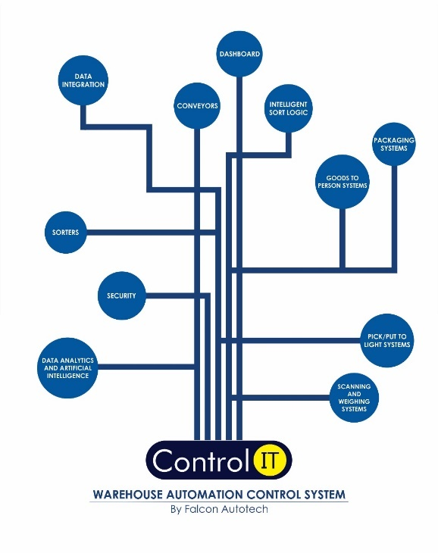

Key Values

Supported Protocols

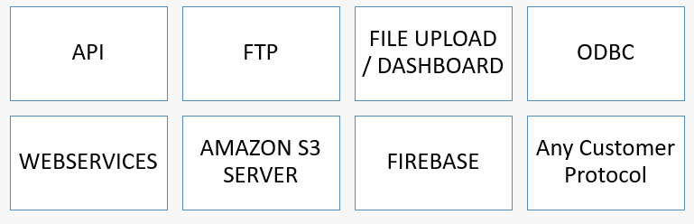

Falcon’s Visual Inspection System (SCADA)

SCADA stands for Supervisory Control and Data Acquisition. It is a system of hardware and software components that allows for remote monitoring, control, and data acquisition of industrial processes or facilities

The Visualization system provided by FALCON (or SCADA) allows the monitoring and control of the different systems delivered for the Flipkart Riyadh Hub. This SCADA system receives from each monitored sub-system all information on their operating status in real time.
At the system monitoring level, the functions performed are:
- Field data acquisition.
- Animated visualization of equipment.
- Representation of the operating mode of the system (nominal, contingency, etc.).
- Alarm management.
- Alarm history management.
- Diagnostic help.
- Failure detection.
- Equipment control.
- Statistics on equipment operation.
- Historical Statistical Report.
- Recording and archiving.
- Safety operator interface.

FIELD DATA ACQUISITION

The field data acquisition function is performed by the SCADA system connected to the sorters' PLCs.
The communication with the PLCs is done using equipped CPU cards that are able to manage the communication with the PLC on the Industrial Ethernet network, without overloading the server.
The acquisition of signals from external systems is carried out via the PLC, using dry contacts.

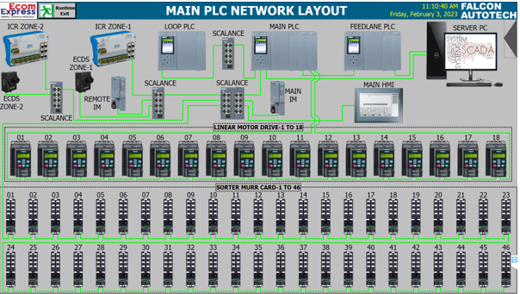

ANIMATED SYSTEM VISUALIZATION

The animated view represents the dynamic graphical user interface that allows real-time monitoring of the controlled systems and the execution of their control procedures.
The various states of the digital signals are displayed on the screen by graphic symbols. All views are web based with responsive capabilities when required so that various devices can be used to display status and information on PC. The types of information that can be displayed on each type of device will be discussed during the design phase of the project.
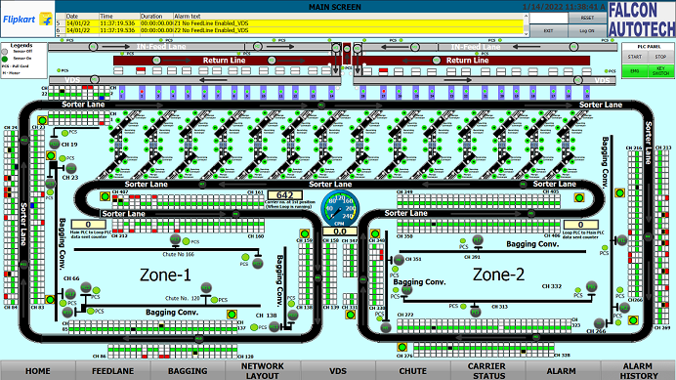

Example of a synoptic view
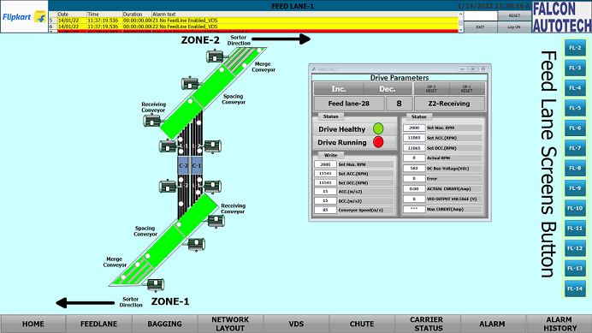

ALARM MANAGEMENT
The alarm pages display a series of information to identify the nature of the alarm or event, the elements involved and the time.
The alarm management includes:
        - The Alarm name.
        - The date on which the above-mentioned alarm was activated.
        - The moment the alarm goes off.
        - The date on which the alarm is activated again.
        - The moment the alarm is activated again.
        - The sub-system that activated the alarm.
        - The area where the alarm was triggered.
        - The name of the beacon that activated the alarm.
        - The alarm state.
        - The alarm value.
        - A complete alarm description.
The historic data of each alarm is stored in the SCADA database. This type of fault detected includes:
          - Sensors.
          - Drive Fault.
          - Lack of monitored equipment.
          - Etc.

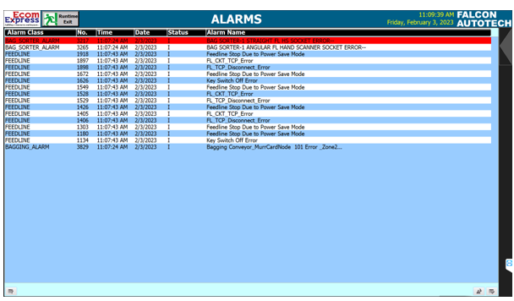
Sample Alarm History Screen

Key Components Make

Items | Make
Belts | Forbo/ Derko
Rollers | Falcon
Cross Belt Carriers | Falcon
Friction Wheel Drive | Falcon
Feed Line Motors | Induction Motors – SEW/ Lenze
Volume Scanners (VMS 4200) | SICK
Weighing Scales | Bizerba/ Mettler Toledo
Encoders | SICK
Sensors | Sick/Leuze/ P&F
PLC | Siemens/ Omron
Control Panels | Rittal/ BCH
VFDs | Siemens/Lenze/ AB/ Omron
Cables | LAPP/ Equivalent
Switch Gear | Schenider/Equivalent
Bearings | NTN/SKF/Equivalent
Power Transmission Systems | Vahle
HMIs | Siemens

Principle of Safety

E-Stops
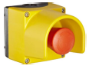

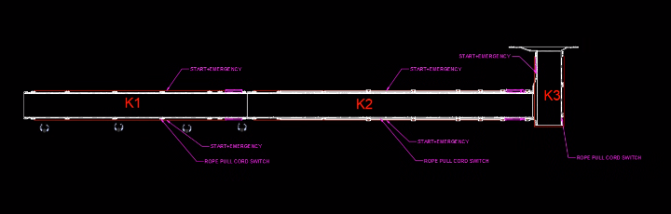
- At Every Conveyor Module – Both sides

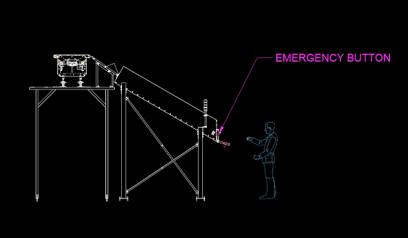
- VDS Chutes

Pull Cords Switch-
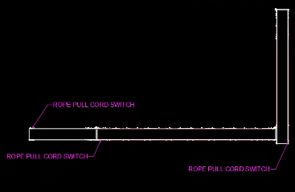
Required for Infeed & Takeout Conveyors

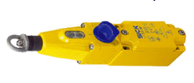

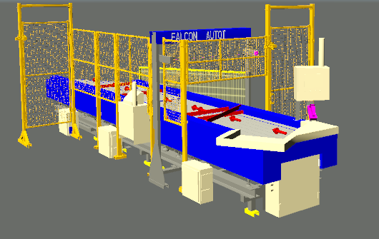

Fencing

- Between Inducts

- Between Inducts and Sorter

Additional Scope-

        - If Safety Barricading at ground to be considered. (Safety fencing & Column Guards). Price- INR 5000.00 per m for fencing and INR 2000.00 for every Skid plate.
        - Estops at CBS Loop & ICR
        - Key management System at Inducts with Fortress
        - FRLS Cables- LAPP/ Polycab/ KEI Make
        - Power Saving Sensors for Conveyors – Optional
        - Safety PLC – Optional
        - Safety Net between Chutes.
        - Energy Meters
        - Safety Gate at ICRs

Program Organisation

Program/ Project Schedule

S.No. | Activity | Timeline
1 | Receipt of PO | Week 0
2 | Project Kick off | Week 1
3 | DAP Submission | Week 5
4 | DAP Approval | Week 7
5 | Detailed Designing | Week 11
6 | Manufacturing & Procurement | Week 19
7 | Inhouse Assembly | Week 23
8 | Dispatch Start | Week 24

*Above plan is tentative, detailed plan will be shared post order confirmation.

Program Management

For this program, proposed approach covers the following aspects:

- Creation and monitoring of the project plan.
- Communication with Flipkart
- Weekly/Fortnightly Meeting Flipkart to share the Project Status.
- Scheduling of the resource management.
- Management of risks and opportunities.
- Management of the requirements.
- Management of the list of anomalies or reservations.

Flipkart Responsibility

Flipkart Responsibilities During the Assembly and Commissioning Phase

- Provision of the site complex and office area facilities.

- Flipkart to provide HPT/ Forklift for material movement for complete duration.

- The possibility of authorizing access to the site and the execution of the installation work up to 7 days a week and 24 hours a day if deemed necessary and if requested by FALCON.
- Free provision, during the installation phase, of the power supply necessary for the installation activities (estimated at 20 kW).
- Provision, during the commissioning phase, of the power supply necessary for the operation of the shipment sorting system free of charge at the date of FALCON need.
- Provision of the IT system functionality in accordance with the specification at the date of FALCON need.
- The customer is responsible for a safe working environment.
- The customer makes arrangements for the working area(‘s) to be protected against direct weather influences.
- The customer provides adequate lighting, heating, and ventilation to create a normal working environment.
- The cost of temporary storage that may be required (other than in the immediate vicinity of the installation site) is not included in the scope of delivery of this quotation. This also applies to temporary storage that may be required because materials are ready for delivery (in accordance with the schedule) but cannot be delivered due to hold-ups on the customer's side.
- The customer is responsible for the demarcation of aisles and danger zones with floor paint.

Responsibilities of Flipkart During the Tests

- Provision of the test loads and barcode labels required for the tests.
- Provision of personnel required for test activities (loading and unloading operations).
- Provision of the necessary information to sort the shipments correctly.
- Verify with FALCON the quality and conformity of the test loads (labels, cartons).
- Will need to provide the necessary staff to collect information on the tests and to verify and confirm test results with FALCON.

Flipkart Responsibilities During the Training

- Free from their usual work, the employees participate in the training for the duration of the training.
- Provision of a list of participants for each available training course 3 days before the start of the course.

- Provision of a classroom equipped with a whiteboard, video projector, projection screen, and enough space for desks or tables and chairs for the trainer and trained staff.
- Check the prerequisites of the people who have to follow the training, e.g. the qualifications of the technical staff.
- The invitation of staff to attend the training courses will be at the expense of FLIPKART.

Warranty Period
Falcon’s offered System comes with a standard warranty of 1 year (Starts from the date of beneficiary use).
The warranty covers the following support:
- 24 X 7 Telephonic, Email and Remote Service Support when required.
- Regular Software updates and Bug Fixes.
- Supply of Mechanical and Electrical components in case of failure (excluding damages as mentioned in the Exclusion Clause)
The warranty does not apply to the replacement or repair of:
- Normal wear and tear.
- Consumables.
- Faulty articles continued:
  - Failure to comply with the manufacturer's recommendations (logistics documentation, Technical Information Note, retrofit document) and the rules of the trade.
  - Negligence or abnormal use of equipment.
  - Anomalies produced by an environment of use, storage or transport that does not comply with the specifications or recommendations of Falcon: packaging, temperature, hygrometry, sector, insulation, etc.
  - A defect due to a cause external to the supplies and services of Falcon.
- Equipment other than that supplied by Falcon.
- Items that can be repaired exclusively by Falcon that have been repaired or attempted repairs other than those carried out by Falcon.
- Items that fail due to normal wear and tear of one or more of its components or whose tamper-evident seals (varnish, strip, etc.) have been broken or whose serial numbers have been removed or modified.
- Items damaged during transport to Falcon due to the use of unsuitable packaging.

Exclusions
The scope of supply includes all parts which are defined in the Supplier’s quotation.

All other parts which are not defined in the Supplier’s quotation do not belong to the Supplier’s scope of supply and are excluded. The following parts are also excluded:

- Server System
- Mobile Carts
- Construction Power
- Steel Works- If not specified
- Collection Trolleys below chutes
- Secondary Sortation
- PC for SCADA.
- Stress free mats
- Insulation mats
- Fans at chutes & Inducts
- Building infrastructure; building structure, doors, fire exits, levelling devices, building extinguisher and fire alarm system, building heating and lighting system.
- Electrical power supply and wiring to the main control cabinets
- UPS for Controls and Drives
- Network Cabling up to the Main Server Rack
- Intermediate wiring to parts which are to be supplied by the Purchaser/others
- Emergency/Uninterruptable power supply
- Fire-alarm and fire protection devices
- Traffic and route markings
- Laydown Area
- Ram protection devices
- Cat walks, bridges, maintenance aisles and platforms
- Assembly tools like forklifts and hoisting machines
- All kind of network incl. Local Area Network (LAN/WLAN), exceeding the scope described in Scope of Supply
- Any Kind of Civil work
- Any adjustment of the Supplier’s scope of supply to local rules and regulations
- X-Ray machines
- Roller cages/ Pallets
- Simulation and 3D animation of the sorter system
- Interface with other equipment not specified in this offer.
- Provision of facilities for the control room (furniture, air conditioning, heating, etc.).
- The supply and installation of fencing around the different corridors.
- Any item specifically indicated as not forming part of the subject matter of the Seller's supply in the offer documentation.

